

UNIVERSITÀ DEGLI STUDI DI MESSINA

DEPARTMENT OF ENGINEERING

MASTER’S DEGREE COURSE IN

ENGINEERING AND COMPUTER SCIENCE

COMPUTER VISION AND DEEP LEARNING

IN DEFECT DETECTION

*Student:* *Advisor:*

**Le Van Huy Prof. Dario Bruneo**

*Co – Advisor:*

**Fabrizio De Vita**

ACADEMY YEAR 2020 - 2021

# Table of Contents

Abbreviations I

*Acknowledgements* II

*Abstract* III

I. Introduction 1

II. Computer Vision (CV) 5

III. Background Knowledge 8

1. Overview of Machine Learning 8

2. Overview of Deep Learning 10

3. Artificial Neural Networks (ANNs) 10

3.1. Neuron 11

3.2. Activation Functions 12

3.3. Layer 22

3.4. Forward and Backward (back propagation) steps 24

4. Gradient Descent Optimization Algorithms (Optimizers) 25

4.1. Gradient Descent (GD): 26

4.2. Batch Gradient Descent (BGD) 27

4.3. Stochastic Gradient Descent 28

4.4. Mini-batch Gradient Descent 28

4.5. Stochastic Gradient Descent with Momentum 29

4.6. Adaptive Learning Rates Methods: 30

5. Convolutional Neural Network 33

5.1. Convolution Layer 35

5.2. Pooling Layer 41

5.3. Batch Normalization (BN) 43

5.4. Fully Connected Layer 44

6. Residual Network (ResNet) 46

6.1. Residual Blocks (RBs) 48

6.2. ResNet Architecture 49

7. EfficientNet 52

7.1. Model Scaling 53

7.2. Compound Scaling Method – EfficientNet 54

7.3. EfficientNet Architecture 57

8. Fully Convolutional Networks (FCNs) 60

9. U-Net 65

9.1. U-Net Architecture 65

IV. Implementation 68

1. Dataset – Image Processing 68

1.1. Data Augmentation 71

1.2. K-fold cross-validation 73

1.3. Data Generation 74

2. Model 74

2.1. Evaluation Metrics 76

2.2. Loss function 76

2.3. Execution Environment 77

2.4. Model Training Process 77

V. Result 79

VI. Future Work Scope 91

VII. Conclusion 92

Bibliography 93

# Abbreviations

|  |  |
| --- | --- |
| AF(s) | Activation Function(s) |
| AI | Artificial Intelligence |
| ANN(s) | Artificial Neural Network(s) |
| API | Application Programming Interface |
| BGD | Batch Gradient Decent |
| BN | Batch Normalization |
| CNN(s) | Convolutional Neural Network(s) |
| CV | Computer Vision |
| DL | Deep learning |
| DNN(s) | Deep Neural Network(s) |
| FCN | Fully Convolutional Network |
| FN | False Negative |
| FP | False Positive |
| FPD | Function of Probability Density |
| GD | Gradient Descent |
| ICS | Internal Covariate Shift |
| IOTs | Internet of Things |
| LReLU | Leaky Rectified Linear Unit |
| ML | Machine Learning |
| NN | Neural Network |
| OD | Object Detection |
| RB(s) | Residual Block(s) |
| ReLU | Rectified Linear Unit |
| ResNet | Residual Network |
| SF | Sigmoid Function |
| SGD | Stochastic Gradient Decent |
| SR | Speech Recognition |
| Tanh | The Hyperbolic Tangent |
| TN | True Negative |
| TP | True Positive |

# *Acknowledgements*

*I would like to give my deep gratitude to Professor Dario Bruneo and PHD Fabrizio De Vita who are advisors, enthusiastically having supported and given me instructions and valuable feedbacks to complete this thesis. And I would like to give a thank Kaggle and Severstal corporation for supplying the data of image and project requirement that is bases of the thesis. I would like to give a thank to Giang Vu who is one of my juniors joined me in researching and supporting me learn about deep learning and the thesis' project problems in the first days. Besides, I would like to give thank my family, and friends who have always been by my side to encourage and create a source of positive energy to help me firmly on the path of completing this thesis. I am very grateful to all of you because this accomplishment would not have been possible without you. Thank you*

# *Abstract*

*The defects of a product or materials in the manufacturing industries are one of the problems that cause headaches and costs for manufacturers as well as companies around the world so far. It is costly in recalling defective products, costly in refurbishing or remanufacturing them, and also in human resources in monitoring and evaluating products before they are put on the market. Because of that, the application of research in artificial intelligence as well as computer vision for defect detection in the manufacturing industries was started a few years ago, with the aim of reducing production. defective products as well as minimizing costs such as recalling products, remaking them, or consuming human resources for product quality assurance. More than that, it is aimed at helping the product have a better and perfect level when it reaches the user. Therefore, in this thesis, I have researched and applied the research results of the forerunners in the field of Deep learning as well as computer vision, although it is not perfect, it also achieved a possible result to contribute in the research and application of artificial intelligence, it plays a small part in the field of IoTs for the manufacturing industry. Specifically, I conducted research on the topic of defect detection on steel surfaces, it was taken from Kaggle's contest titled "Severstal: Steel Defect Detection", which was a quite big contest held in 2019. In this thesis, I went to solve the requirements of detecting and classifying defects on the steel surface through the image data set provided by the Russian corporation Severstal. More specifically, I have implemented mainly semantic segmentation and accompanied by some other techniques in deep learning to solve this problem.*

# Introduction

In the era of industry 4.0, with technological achievements that the world has achieved through research on artificial intelligence (AI) from the last century, accompanied by well-developed infrastructure, machinery and equipment applying cutting-edge technology, which help IoT systems are gradually growing stronger and more popular, they have such a high applicability in most aspects of life. Currently, there is a rapid development of smart health care systems, smart agriculture, smart cities, smart homes, smart industries, and so on... all these "smart things" are built on top of the distributed systems and physical infrastructures of each field. If the distributed system, which is considered as the "backbone", is the main architecture building on the internet of things (IOTs) system, help the IOTs system operates smoothly, then artificial intelligence acts as a "cognitive area of the brain" in the IOTs system. It helps the system to collect and process information to make decisions, more specifically here is computer vision of deep learning, which is one of the indispensable components in the IOTs system. Using cameras in tandem with sensors such as: temperature, light, sound, smoke, or GPS in most popular IOTs, they are one of the important devices used to capture collect data about the system's cloud and use trained deep learning models to make decisions on these data, or use these data to train and improve the "brain" of the system IoTs are getting better and better for specific purposes of the system.

With the birth and development since the 1950s of the last century, computer vision, which, is the one of the sub-disciplines of AI, has made progress as well as achieving outstanding achievements in the present. Its applications play a very important role in these systems. Looking at deeply, Smart Homes often use them in facial recognition, identification tasks such as: people, objects, pets, or even identifying and alerting thieves to protect you and your family. Smart cities with applications for developing autonomous vehicles, or traffic monitoring camera systems, smart parking lots that let you know how many spaces are available, or smart airports that help for identification identity. Smart heaths with supports for doctors in diagnosing diseases by predicting phenomenon in images from x-ray, endoscopy, ultrasound or tomography. Smart agriculture with monitoring and diagnosing the health of crops and livestock. Smart industries with camera systems for production or monitoring of the production process of products to ensure quality, to reduce and to avoid costly human resources in tasks that can replace by using machines. Specifically, defect detection on steel surfaces based on computer vision is one of the very useful applications in the industry of manufacturing steel materials or products made from steel, it helps enterprise can identify product defects and evaluate product quality, or help reduce costs and improve product quality.

In the next parts of the thesis, I will briefly cover computer vision and its common applications in technology as well as in life and production. Then I will go to write about the knowledge in deep learning is also such as artificial intelligence is used for this project, in detail, I will clarify the basics of Artificial Neural Network **(**ANN) and important components of the network such as layers and types of layer, activation functions, Convolutional Neural Network (CNN) and some state-of-the-art architectures of CNN like ResNet being built from Residual Blocks, EfficientNet with applying 3D compound scaling method, U-Net with U-shaped structure including encoding part and decoding part for image segmentation work; or about optimization methods that are commonly used in model training work.

Continuously, it is the implementation of the solution that I came up with as well as the obtaining results, particularly, I went to find a solution to the defect detection problem on steel surface through the requirements of Kaggle's contest with the accompanying dataset of Severstal corporation by applying the state of the arts models with a combination of them to give positive results. It is the method of semantic segmentation on the image dataset by a combination of U-Net as a master architecture and versions of ResNet as the backbone architecture for U-Net, or another combination of U-Net and versions of Efficient, is respectively the overall architecture and the corresponding backbone in the model. Furthermore, given the data set was provided with an imbalance in defect type, so I went to make them a balancing in the data type by augmentation method and using K-fold method to evenly divide the types of data and the amount of data for the training data set and validating data set to help the learning model give an objective result and improve the prediction accuracy at the testing data set. In addition, applied an optimization method as Adam with default values ​​for parameters to help the model learn faster and more accurately. Using 5 folds and going through over 20 - 30 epochs for each fold in the training model, I got good results with accuracy ranging from 90% - 94% with validating data set and around 68% - 71% with testing data set through model evaluation. The following step was to make an evaluation for the model’s performance with techniques of Accuracy Classification Score and Multi-label Confusion Matrix. Accuracy Classification Score method gave results ranging from 72% - 82% in total prediction of defect types, and results from 90% - 95% in predicting each defect type. Then, the Confusion Matrix method also gave quite optimistic results of classifying labels between ground-truth masks and predicted masks of test data set. At final step, I went into re-checking the results with the naked eye by rendering the original image with ground-truth masks and the original image supplying predictive masks based on the threshold number of pixels that the model makes predictions for each defect type. To understand the solution in more detail, I will cover them in the implementation section.

Final section is conclusion with an overview of the thesis as well as the implementation and results achieved.

# Computer Vision (CV)

Computer Vision is an Artificial Intelligence (AI) area which deals with computational approaches for assisting computers in understanding and interpreting the content of digital images [38]. As a result, computer vision seeks to enable computers to view and comprehend visual data received through cameras or sensors to identify, and understand the visual world automatically by emulating vision of human being. In particular, the goal of computer vision is to artificially mimic human vision by allowing computers to comprehend visual stimuli meaningfully [39]. As a result, it is also known as machine perception. CV remains one of the most difficult subjects in computer science because of owing to the vast complexity of the varying physical world. In fact, human sight is the result of a lifetime of learning with context to train how to detect certain things or human faces or individuals in visual settings.

CV is not a newly discovered technology nowadays because the earliest attempts with it began in the 1950s, and it was used to analyze typewritten and handwritten text after that [39]. At that period of time, computer vision analysis processes were very straightforward, but they needed a significant amount of work from human operators who had to manually input data samples for analysis. So, it was difficult to supply a large amount of data manually. Furthermore, the computer capacity was insufficient making the error margin for this analysis was quite large. There are numerous supports for CV nowadays. Cloud computing, when combined with powerful algorithms, has the potential to help us tackle even the most difficult issues. The combination of new hardware, clever algorithms, and the massive amount of publicly available visual data that we generate on a daily basis is responsible for propelling computer vision technology ahead. Modern artificial vision technology uses machine learning and deep learning approaches to train robots to recognize objects, faces, or people in visual settings based on a large pool of picture and video data. As a result, computer vision systems employ image processing methods to enable computers to locate, identify, and evaluate objects and their surroundings using data from a camera.

Moreover, CV systems are trained to examine products, monitor infrastructure, or a manufacturing asset in order to detect faults or difficulties in thousands of products or processes in real time. It can swiftly outperform human capabilities because to its speed, continuity, objectivity, correctness, and scalability. Applications of CV are employed in numerous industries, including security and medical imaging, as well as manufacturing, automotive, agricultural, construction, transportation, smart cities, and many more. More use cases become conceivable as technology progresses and becomes more versatile and scalable. In addition, the most recent deep learning models outperform humans in real-world image recognition duties such as facial identification, image classification, object detection, and image segmentation.

**Image classification:** Accepting input is an image and outputs the labels for duty of classification along with several measures (loss, accuracy, probability, etc.). For example, a picture contains a duck may be classed as a label of "duck" with some probability, whereas an image contains a chicken being made a define as a label of "chicken" with several probabilities [43].

**Object Localization:** Helping detect the present of an object which is bounded in a box within an image, receiving an input of image and returns the box location in the formation of width, height, and location [40].

**Object Detection:** Doing both classification and localization which receive an input of image and generates one or several bounding boxes, each box contains the attached label of class. These methods are powerful enough to handle localization and classification for multi-class and objects containing numerous occurrences as well [43]. However, the bounding boxes in object detection are always a form of rectangle. As a result, if the item contains the curvature part, it does not aid in establishing its shape, and object detection does not have an ability to estimate some measurements in high accuracy such as an object's area or perimeter from an image.

**Image Segmentation:** Being an extra extension in detection of object. It helps us designate the existence of an object in the image using pixel-wise masks built for every single object. The method is more detailed than producing of bounding box since it allows us to determine the geometry of every single object appearing on image. This granularity is useful in a variety of applications, which includes medical image processing, satellite imaging, and so forth [43]. Many pictures segmentation approaches have lately been proposed. Mask R-CNN, U-Net are the popular models in segmentation. The segmentation has two essential forms. Firstly, instance segmentation can make an identification for the borders of an item and labeling its pixels by distinct colors [41]. Secondly, semantic segmentation is the process of marking each pixel as a label in an image including the background, the pixel is with a distinct color based on its label of class, or its category [41].

# Background Knowledge

## Overview of Machine Learning

Machine learning (ML) is an artificial intelligence (AI) technology allowing computers to make an automatic learning and improvement based on experience without a flagrant programming. ML is focused on the development of computer programs being able to make an access and utilization of data to learn themselves. Its progress of learning starts from data or observations, for example: a direction of finding out data patterns to make decisions with a better quality relied on instances being supplied in the future [37]. The fundamental purpose of helping computers have an ability to learn autonomously, which does not contain any participation or assistance of people and then adjust activities of them suitably. Then, ML allows for the examination of enormous amounts of data, although it generally produces quicker and more exacting results in identifying valuable possibilities or risky hazards, it probably necessitates more time and resources to train it precisely. In addition, the combination of ML with AI and technologies of cognition is able to increase its efficiency in processing massive amounts of data. Algorithms of ML are usually classified to supervised or unsupervised [37].

* **Supervised** ML algorithms have a potentiality for predicting events of the future by applying what they learnt previous on new data by utilizing labeled examples. The learning method generates a function of inference to predict output results based on a study of a known set of training data. After going through an adequate process of learning, the system may supply goals for any input of new data. Moreover, the algorithm also has the function of making a comparison between its own output and output of expectation or correct output, and gives out an error detection to make a suitable adjustment for the model [37].
* On the other hand, techniques of **unsupervised** are utilized when the material required to train is both unclassed and unlabeled. These algorithms learn about mechanism of computers for producing function of inference from data without being labeled, which is to express a unseeable construction behind. Although system does not determine the correct output, it investigates the data and is able to make conclusions from sets of data to characterize concealed constitutions of unlabeled data [37].
* **Semi-supervised** methods sit midway between supervised and unsupervised learning because they train with both unlabeled and labeled data, which is often a little of labeled data amount and a huge amount of unlabeled one. This strategy allows systems to significantly enhance learning accuracy. Semi-supervised is particularly utilized when the collected labeled data requires experienced and agreeable resources for training from. Besides, obtaining unlabeled data usually does not necessitate the use of supplemental resources [37].
* **Reinforcement** ML algorithms are a type of learning system which is several interactions with its around environment by performing executions and exploring rewards or errors. The most essential aspects of these algorithms are making several searches of trials and errors and postponed rewards, which enable devices and agents of software to find an optimal behavior at a specific scenario to making an improvement for their performance to maximum point. For the agent to know what action is the best, there is a requirement of reward's simple feedback, which is called as the signal of reinforcement [37].

## Overview of Deep Learning

Deep learning (DL) is a small field belong to ML and AI which utilizes a bunch of layers of ANNs to reach achievements of "state-of-the-art" accuracy in tasks like speech recognition (SR), language translation, object detection (OD), and others. There is a difference between techniques of DL and typical techniques of ML, DL is able to learn automatically from data such as text, image or video without the utilization of hand-coded rules or knowledge domain of human. When given more data, their architectures with high adaptability are able to learn directly from raw data to achieve an improvement of prediction's accuracy [42].

DL is widely employed in applications such as CV, systems of recommendation, and AI in conversation. DL is applied for CV software to learn from digital productions such as photos and videos. The applications of Conversational AI assist devices in understanding and communicating by natural language. Besides, language, user's behaviors and digital productions are used by recommendation systems to provide searching results and services which are suitable and significant [42].

## Artificial Neural Networks (ANNs)

The concept of ANNs was built on the inspire of human brain biology characteristics, Cybenko [1] it gave out a substantiation which there is a hidden layer including neurons with a number of specific limitations, having ability to make an approximation for any unstopping function to achieve any desire of precision in a neural network. It included a group of ML models having potentiality to “learn” to execute or perform some specific tasks based on supplied examples. In general, these networks were created by a group of units or nodes connected each other like a simulating version of neurons in human brain, which called artificial neurons.

### Neuron

Analog electrical signals flow inside biological neurons, while digital values present as the signals for artificial neurons. Each artificial neuron has an output being computed by using a function of the sum of the input signal values with generally added bias, the connection between the neurons as known as edges, in each connection contains an adjustable model parameter named weight that can be “learned” through a process called “model training”. The strength of the synaptic will determines the interaction’s level between the neurons, this function combines the neurons, bias and weights in the connections called “activation function”, and there are several activation functions that mean there is not only one fixed activation function for ANN, and we can choose the activation function for the network’s output. These functions will be mentioned later in this thesis.

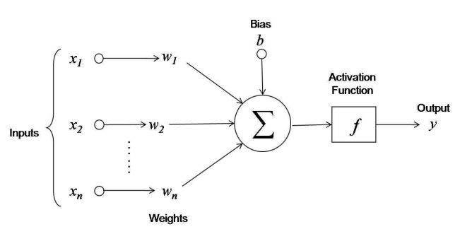

*Figure 1: Artificial Neuron Structure [46].*

### Activation Functions

Activation Functions (AFs) in Neural Network (NN) are a component which is very essential in Deep Learning. AFs help give out a determination for a Deep Learning model's output, the accuracy and effectiveness of computation of the training model making a decision on the success or failure of a NN system. AFs also have a great influence on the convergence and convergence speed of NNs, or in some cases, AFs can prevent NNs from assembling right from the start.

AFs are presented in equations of math and this function is attached to every single neuron in the network and produces a determination of being activated or not, relied on the input data fits prediction of the model or not, which also help manufacture a normalization for every single neuron's output with a range of zero to one or minus one to one, depending on the type of AF being used in the layer or network. Additionally, another aspect of AFs is they have to have efficiency in computation because of being computed over millions or even billions of neurons for every single instance of data. And modern NNs utilize a technique of backpropagation for training the model.

The main reason that NN models stand out from machine learning models is their ability to solve non-linear data problems through AFs of hidden layers, at which execute the task of solving problems for complex nonlinear relationships between data features and model outputs.

As mentioned earlier, in a NN, the input data, is fed to the neurons which are located in the input layer. Every individual neuron has ability to produce a outcome as an output from the multiplication of its input and its weight, this output is then passed on to the following layer. So, AFs are applied in NNs to be on duty of computation for the weight input's sum and biases, being utilized to make a decision on a neuron be activated or not. It executes a manipulation of the supplied data via several handlings of gradient, or gradient descent (GD) in typical and thereupon give out a production for a NN's output, including the parameters. These AFs are usually known as a reference for a transfer function in some documentation or research papers. Furthermore, relying on the function they deputize, AFs have a potentiality of being either linear or non-linear, and they are used to modulate the outputs of NNs in a diversity of areas ranging such as: segmentation, object recognition, classification, speech recognition (SR), cancer detection systems, finger print detection, and so on… [12]

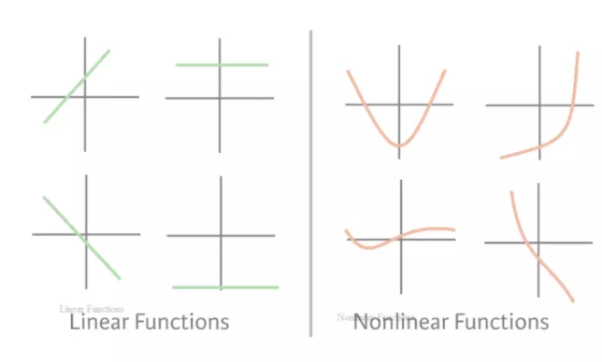

*Figure 2: Linear and Non-linear functions [47].*

Although in fact that there are many types of AFs, in this article I will only mention some of the AFs that are commonly used in current CNNs architectures like sigmoid, softmax, hyperbolic tangent (Tanh), rectified linear unit (ReLU) and Leaky rectified linear unit (LReLU).

#### Sigmoid function (SF)

Sigmoid Function is also called the Sigmoid curve. This is built relied on a mathematical function characterized by a curve with S-shaped, which is one of the non-linear activation functions most widely used. If being familiar with some machine learning models, probably still remembering Logistic Regression - as one of the simple algorithms for binary classification problems, which is quite effective. The "soul" of Regression is this Sigmoid function. The sigmoid is a continuous nonlinear function, allows to pass real numbers as its input and gives a production of results in the range 0 to 1, is considered probabilistic in some problems. Suppose you trained a NN to images classification of birds and dogs, what a classic problem, where bird is 1 and dog is 0. Basically, when your Model returns a value greater than 0.5 meaning the image is of a bird, or the value less than 0.5 means the image is of a dog.

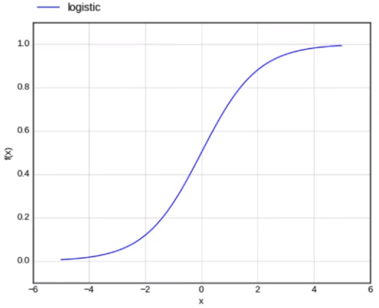

*Figure 3: Sigmoid function.*

In the Sigmoid function, a small adjustment from the input results in a no relative change for output. It gives a smoother and more continuous output than input, so, it has derivative in everywhere [13]. The Figure 4 shows the formular of sigmoid function:

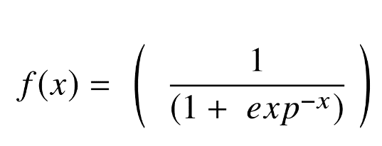

*Figure 4: Sigmoid function equation.*

In the formula, x represents for the network’s output, and f(x) is its function, and exp stands for the Number of Euler. As a result, if x goes ahead to the infinity of positive, the value of expectation f(x) becomes 1. In contrast, if x approaches to the infinity of negative, the predicted value of f(x) becomes 0. And if the result of the sigmoid function is greater than 0.5, that label is classified as class 1 or positive side, and if it is less than 0.5, classified as class 0 or negative side.

On the other hand, the sigmoid has significant shortcomings such as gradients of sharp damp while doing backpropagation starting from deeper hidden layers back to layers of input, saturation of gradient, sluggish convergence, then output of having non-zero centered, which is cause of having various passageways for updating of propagation. another AF type, such as Tanh, has been recommended to address some of the shortcomings of the Sigmoid AF.

#### SoftMax function

SoftMax Function is an exponential averaging function that calculates the probability of an event occurring. In general, this algorithm calculates the probability of a class occurring out of the total of all possible classes. This probability will then be used to determine the target class for the inputs. Specifically, the SoftMax turns a vector with k - dimensional of any real numbers become a real-valued k-dimensional vector summing to 1. Its input value might be zero, minus number, or positive number, however the function will always turn them into a value in the range (0:1]. The SoftMax Function is calculated following this formula:

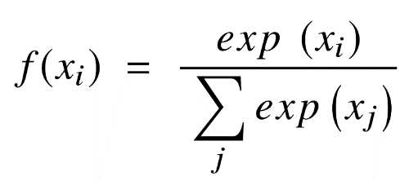

*Figure 5: SoftMax function equation.*

Where (xi are vector of input values for the function from x0 to xn, in which all the values can be any real number, positive number, negative number or zero. Next, exp(xi) is the standard exponentiation function is applied to each input value returning a positive value greater than 0. This value will be very small if the input is negative, and very large if the input is positive and it is an uncertain number in the range (0:1] as the requirement of a probability.

As such, they may be called “probabilities”. If there is a negative number or very small number of input value, the function transforms them into a tiny probability. In contrast, if there is a large input value, it will be converted to a large probability. But the probability is always greater than 0 and less than 1, or equal to 1. So, the sum of all probabilities is always 1 and the function brings a lot of benefits such as:

* Optimized when calculating the maximum probability in the model parameter.
* The property of the SoftMax makes it satisfactory for interpretation of probability, which is very beneficial in ML.
* Normalization of SoftMax is a method to minimize the effect of extreme values ​​or outliers in data with no having to modify the original data.

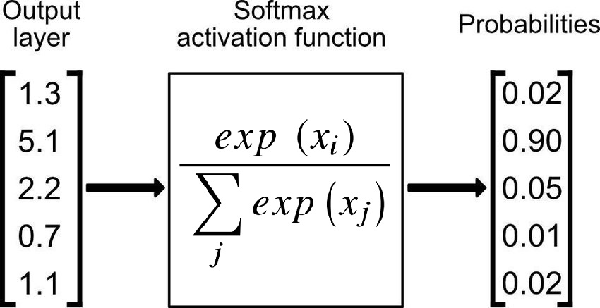

*Figure 6: Softmax function applied in output layer of a network for classification task.*

For the reasons mentioned above, the function of SoftMax returns the value of probabilities for each class in multi-class models, with the class of intention having the supreme likelihood. The function may be found in practically all of the deep learning's output layers architectures where it is used. Adding, there is a distinctness between SoftMax and Sigmoid, which the Sigmoid is utilized for classification of binary and the utilization of SoftMax for the tasks of diversity classification.

#### Rectified Linear Unit (ReLU) Function

In 2010, Nair and Hinton introduced the AF of rectified linear unit (ReLU), which has been the supreme extensively utilized AF for applications in the DL field, bringing a state-of-the-art result till currently [17]. In general, The ReLU AF has an expressive speed of learning AF proven to be the most extensively and successfully applied function [14]. In DL, it outperforms and generalizes the Sigmoid and Tanh activation functions [18]. In particular, there is a representation of a roughly linear function in ReLU function and hence preserves the features of models in linear that make them easier to ameliorate using the approaches of gradient decent. The mechanism of the ReLU AF, which applies a functioning of threshold to each element of input having values smaller than zero to be replaced to zero, and the formular of the ReLU AF as follows:

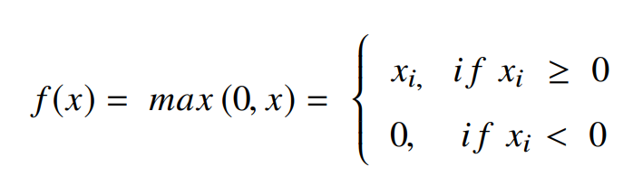

*Figure 7: Rectified Linear Unit function equation.*

The ReLU will correct the inputs' values which are smaller than zero, they are driven to 0 and removed the issue about gradient of vanishing. Mainly, the ReLU is put to utilize into the hidden units of deep neural networks (DNNs). Besides, another AF as sigmoid or SoftMax is often applied in the network's output layers with popular purpose of classification in image [12] and SR.

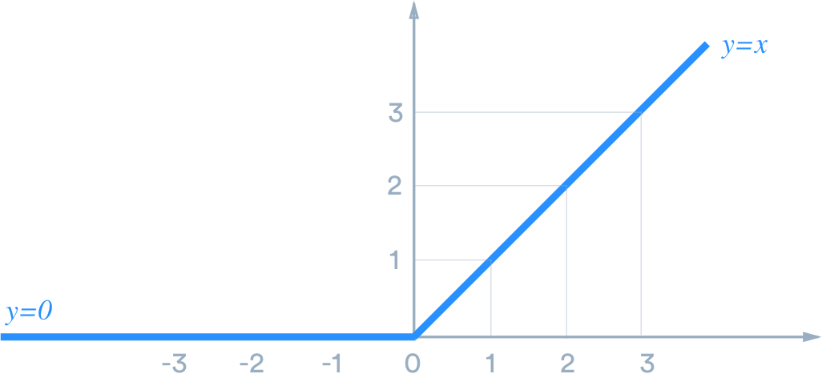

*Figure 8: Rectified Linear Unit Function [33].*

There are many advantages when using ReLU. In detail, the fundamental advantage of ReLU in computation is that they bring a more expeditious computation because of not needing to quantify divisions and exponentials of them, directing to an increment of achievement of overall computation [18]. creation of sparsity in the hidden units is another feature of the ReLU, which calculates the square value from 0 to value of maximum. The ReLU exists an issue which it readily becomes overfitted when made a comparison with the function of sigmoid, despite utilizing the approach of dropout to discounting the overfitting's influence of ReLUs and the rectified networks enhanced deep neural network (DNN) performances [19].

There is a notable weakness in the ReLU, which it is occasionally brittle during training, leading to the death of the several gradients. This will make neurons to be dead and direct weight updates to inactivate data points in the future, hampered learning because of dead neurons result in zero activation [3]. So that, the leaky ReLU was offered as a solution to the dead neuron problem.

#### Leaky ReLU

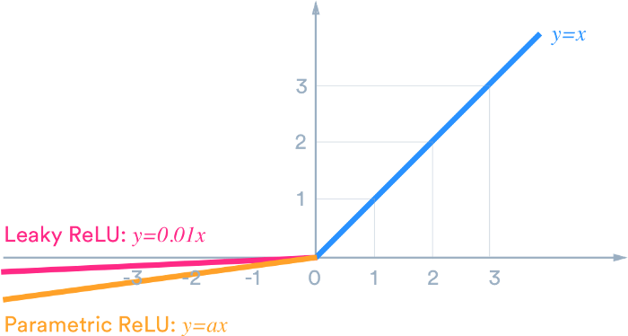

*Figure 9: Leaky Rectified Linear Unit Function [33].*

The leaky ReLU was released in 2013 that give out several mini slope of negative to the ReLU for maintaining and stay survived the updates for weight throughout the phase of propagation. The building of the alpha parameter serves for the solution to issue of dead neuron of the ReLUs, which ensure that the gradients are not fixed zero anymore during training. The computation of the LReLU bases on an unchanged tiny value of gradient for the negative gradient α in the range of 0.01; hence, the computation of LReLU AF is presented following this formula:

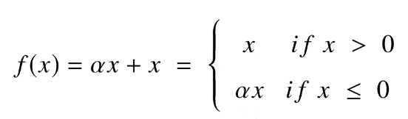

*Figure 10: Leaky Rectified Linear Unit function equation.*

The comparison of the ReLU to an exception of no having zero gradients over the entire of time, which report a similar result. Therefore, excepting of distribution and sparsity in the comparison of ReLU to Tanh, no having any noteworthy enhancement of result. As a result, Leaky ReLU offers two advantages:

* Because it lacks zero-slope portions, it solves the "dying ReLU" issue, so training process is expedited. And, the "mean activation" near to zero is evidence for speeding up training. (It aids in keeping the diagonal entries of the Fisher information matrix short, but it can disregard judiciously.) Unlike ReLU, leaky ReLU is more "balanced," and as a result, it may learn faster.
* Keep in mind that the outcome is not always consistent. Leaky ReLU isn't necessarily better than regular ReLU, and it should only be used as a last resort.

#### Hyperbolic tangent function (Tanh)

Another form of AF utilized in DL is the hyperbolic tangent function, which has several versions employed in applications of DL [14]. Tanh is built as a zero-centered function that is silkier with a range of minus one to one, and its output is given by:

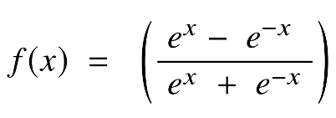

*Figure 11: Tanh equation.*

Because of supplying higher training performance for multilayer NNs than the SF, tanh has become the favored function over the SF [15]. Otherwise, the function of tanh, like the SFs, was unable to overcome the gradient of vanishing problem. The advantage key of this function is producing a generation of output from zero - center supporting in the operation of backwards progress.

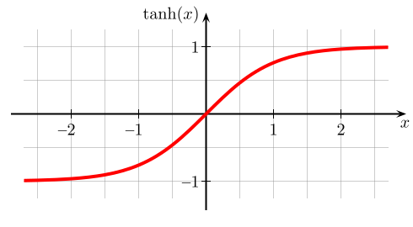

*Figure 12: Function of Tanh with values moving in range [-1: 1].*

The tanh has a specialty which is capable of an accomplishment of gradient value equal 1 in case of there is only zero value of input, that equivalent to x equal zero. As a result, the tanh generates several inactivated neurons within progress of computing. The unworked neuron is a situation of which its weight of activation occasionally is employed similar to a consequence of gradient of zero. In addition, this obstruction of the tanh prompted additional study in AFs to remedy the issue, giving rise to the ReLU AF. Furthermore, the tanh function has mostly been employed for SR and natural language processing in recurrent neural networks [16].

### Layer

All neurons are linked directly in network, on the other hand, they are grouped into subsets of neurons known as layers, which are generally connected in a sequential way based on the activation function in every node to compute nodes’ outputs from node’s inputs. In detail, the neurons in a layer are made a connection to single set of neurons in both previous layer and to another one in next layer. Because of the modeling of ANNs as a connection of a neurons’ structure in layer, neurons’ outputs at a certain layer become neurons’ inputs at the following layer, which networks are understood as feedforward NNs. There are no loops in present layer, therefore the inputs are always sent forward. As a result, the neurons into a layer cannot be connected with each other. When all of neurons in layer are created a connection to all other ones belonging to prior layer and following layer, being called “Fully Connected Layers”, this state of the connection is kept in whole network as a series of fully connected layers that will be called “Fully Connected Neural Network”.

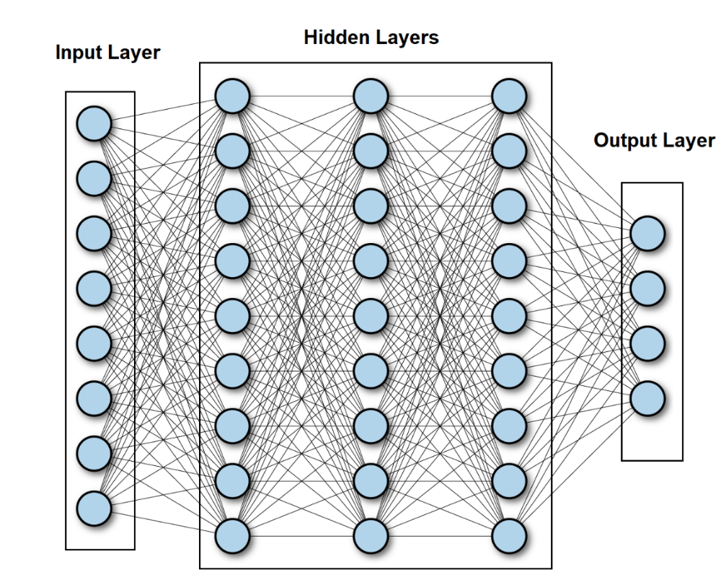

*Figure 13: Fully Connected Neural Network [45].*

As Figure 13 shows above, there is an existing of 3 kinds of layer inside a network, they are layers of input, hidden, and output. Specifically, Input layer represents for input of the network and the number of nodes as known as neurons are size of the input that we call “input dimension”. The hidden layers lay on the middle of 2 layers of input and output, there is an ability of existing so many hidden layers in a network, however, there is single input layer and single output layer in general, the output layer represent for the network’s output. In addition, the bias contains in input layer, not in output layer. Although simple decisions are made at the first layer relied on the input, sophisticated judgments are made at the second layer depending on determinations established at the first layer. As one moves into the network more deeply, more difficult and judgments of abstraction emerge. The phrase deep neural networks refer to a network with numerous hidden layers.

### Forward and Backward (back propagation) steps

As mentioned before, there is a journey of the signals with an order starting from input layer, hidden layers and till output layer; which operations performed over the values received from the nodes in previous layers (in all layers but in the input layer) and whole activation function results are sent forwards to the next layer till the layer of output. However, it is not the end of process. After getting the result of output layer, there is a backwards process named back-propagation applying in here as known as training step for ANN. The algorithm is utilized to productively train a NN via a technique being known as chain rule. Simply, the action of backpropagation is a journey of backward after every single journey of forward move through a network, while there is an adjustment of the parameters of models (biases and weights), which helps minimize the error for network’s result, it is called “loss function” or “cost function” which is the evaluation between predicted and expected output at the final point of forward step. Basically, this function calculates the gradient of the loss function to every single parameter in network respectively that means it works from the top of the model (output layer) to the bottom of the model (input layer) for calculating the contribution of each parameter in that value [2], which updates the weights until reaching the minimum value. Furthermore, the key point of calculating the minimum value for loss function is gradient descent, which is a progress of determining the modifications needed to give out the minimum of the loss and optimization of the model becoming a specific evaluating measurement by calculating the derivative of the loss function [3].

## Gradient Descent Optimization Algorithms (Optimizers)

During the training phase, we frequently modify and change our model's parameters (weights) in order to try to minimize its loss function and help produce predictions as optimal and accurate as possible. As a result, optimizers were developed to assist in resolving this issue. They make a combination between parameters of model and function of loss by making updates of the model for replying to the loss function's output. In other terms, optimizers are techniques or approaches which are utilized to help error function (loss function) reaching a minimum value or to make production efficiency peaking a maximum value [28]. The optimizers are built from functions for math being influenced by learnable parameters of the model, they are biases and weights. Additionally, the assistance of optimizers in determining adjustment of learning rate and the weights of a NN for decreasing losses becoming lowest. In a nutshell, the optimizers will mould your model into its most accurate possible form by tinkering with the weights [28]. And the loss function serves as a guide to the terrain, informing the optimizer whether it is travelling in the correct or incorrect path. There are several common optimizers such as “Batch Gradient Decent” (BGD), “Stochastic Gradient Decent” (SGD), “Mini-Batch Gradient Decent”, SGD with Momentum, Adaptive Learning Rate methods (AdaGrad, RMSprop, Adam).

### Gradient Descent (GD):

Gradient descent is known as a main algorithm for purpose of optimizing model, which is commonly-utilized for training ML models and NNs [4]. GD is built relied on a function of convex to iteratively change parameters for minimizing a provided function to its local reaching to a lowest value. In the other words, GD gets started by defining the initialized values of parameter, and then customizes iteratively these values for the given cost-function to become the lowest one. Deeply, a gradient is a function’s derivative with several input variables. In terms of mathematics, a gradient is known as the function’s slope, and it is intelligible measurements of all weights’ modification in relation to modification of error. Specifically, the steeper the slope and the faster a model can learn, the higher the gradient. However, if the slope is zero, the learning model will be stopped. A gradient is understood as a "partial derivative" ​of regarding to inputs of it.

Imaging that a blindfolded man wants to hike down to the bottom of a valley from the top of a hill with as few steps as possible. He might begin going down the hill by taking large steps in the sharpest direction, which he can do as long as he is not close to the bottom. However, as he gets closer to the bottom, his steps will become smaller and smaller in order to prevent overshooting it. The gradient can be used to mathematically characterize this process. The learning rate η is determinations for size of steps that we are able to get an achievement of the lowest local value. Similarly, going ahead the slope direction of the surface that is produced relied on downhill of objective function, keeping on as far as reaching to a valley [5].

To achieve the purpose of minimizing the local value for GD, there is a relevant selection for learning rate value, which is not both excessively low and excessively high. It is very essential because of excessively large steps could fail to fall down the lowest local value since it jounces in range of the convex function of GD. Besides, GD will finally fall down the lowest local value if learning rate is set to an excessively low value, but it may take a lot of time [6]. So, the key point is choosing an optimal learning rate that helps model converge to the minimum value without spending much time.

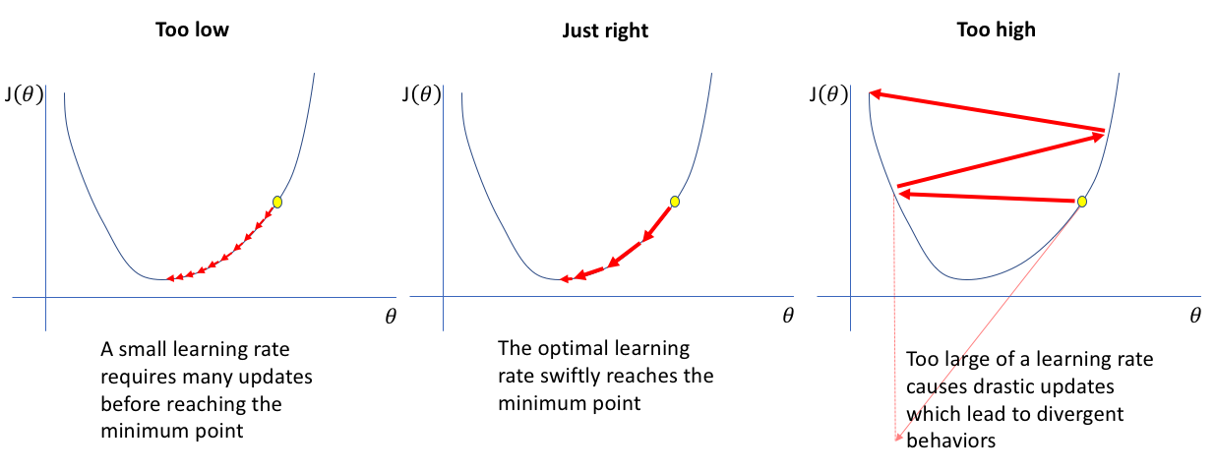

*Figure 14: Learning rate choices that decide gradient descent result [44].*

GD has three forms that distinction of the number of data being utilized to find the gradient of objective function. There is an exchanging about the exactness of the parameter updates and the time it spends completing an update relied on an amount of data.

### Batch Gradient Descent (BGD)

Batch gradient descent calculates a sum of error for every single point in train data set and updates the model after all instances of training being handled an evaluation. This procedure is known as an epoch of training. Though batch supplies an efficient calculation, it still has an ability to take such a much time to execute big sets of training data because it must keep all data in memory [5]. BGD also frequently yields a stability of convergence and error gradient, although the convergence point is not always the best, locating the lowest local value rather than the lowest global one.

### Stochastic Gradient Descent

SGD performs an epoch of training for every single instance in the set of data and makes an update for the parameters of every single instance of training in a period of time. They are easier to remember because of holding an instance of training only [5]. In spite of the fact that the recurring updates provide more specific and rapid, they are able to lead to computational efficiency losses when it be compared to batch gradient descent. Despite having ability of noisy gradients production, these frequent updates can also aid in escape the lowest local value and locating the global value.

### Mini-batch Gradient Descent

Combination of BGD with SGD ideas gives out Mini-batch gradient descent, which divides the set of training data into tiny batches and handles to update every single batch of those. The method reaches a balanced achievement between batch gradient descent's computing efficiency and stochastic gradient descent's speed [5].

Besides, gradient descent has its own set of challenges such as: points of saddle and local minima, gradients of exploding and vanishing.

* Local minima resemble global minima in shape with the slope of the cost function increasing at each side of the present location.
* Points of saddle happen when the minus gradient appears just at a side of the point, a side will fall down to the lowest local value and the other side will peak to the highest local one. Its shape looks like a horse's saddle.
* Vanishing gradients happens when the gradient is too small. The gradient continues to shrink when travelling backwards in progress of backpropagation, leading the learning of the earlier levels of network will be slower than layers in the following. When it occurs, the parameters of weight are updated till the point when they become inconsequential, it means 0, the consequence of an algorithm which does not have the ability to learn anymore.
* Exploding gradients occurs in case of achievement of the excessive big gradient, resulting in an instability of model. The weights of model shall get excessively huge and be given out as “NaN” finally. an approach to this problem is utilization of a technique of dimension reduction, which has an ability to reduce model convolutedness.

### Stochastic Gradient Descent with Momentum

SGD has difficulty navigating ravines, which are widespread around local optima and are regions where the surface curves considerably more steeply in one dimension than another. Consequently, there is a swaying of SGD on the slopes of gorge, which make only sluggish progress from the bottom toward the lowest local value [28]. That is the reason why momentum was established to reduce extreme volatility in SGD and soften model's convergence. Moreover, it promotes for assembling in the proper leading while decreasing variation in the extraneous direction. This approach employs another hyperparameter known as momentum, denoted by the symbol "γ".

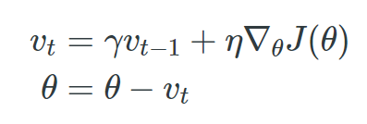

*Figure 15: Momentum Formula [29]*

Some implementations swap the equations' signs. Typically, the term of momentum γ is initialized to 0.9 or an equivalent number. We basically use momentum to drive a ball down a hill. As it rolls downhill, the ball gains momentum, increasing faster and faster (until it achieves its terminal velocity at the point being resistant by the air, i.e. γ < 1) [29]. The term of momentum increment for dimensions has the point of gradients in the equivalent directions and has a decreasing of dimensions having unstable directions in gradients. Consequently, there is an achievement of quicker convergence and less oscillation. Although momentum helps eliminate swaying and high variance in the parameters and congregates quicker than GD, there is a hyper-parameter which must be added and adjusted manually and precisely [28].

### Adaptive Learning Rates Methods:

The difficulty in employing schedules of learning rate is relied on their hyperparameters being established before and are strongly dependent on the model type and issue. Another issue is that all parameter updates use the same value of learning rate [29]. If the data is sparse, we desire to update the parameters to a different extent. With this cause, AdaGrad, Adadelta, RMSprop, and Adam are adaptive learning rate algorithms that offer an alternative solution for traditional SGD. These per-parameter learning rate approaches give a heuristic approach that does not has the need for costly manual tuning of hyperparameters for the agenda of learning rate.

AdaGrad, in summary, conducts greater changes for more inadequate parameters and more slightly changes for less inadequate ones. It performs well with inadequate data and in large-scale NNs of training. Nevertheless, during training deep NNs, its monotone learning rate is frequently excessively aggressive and stops learning too soon, that means AdaGrad makes learning rate changing adaptively in iterations and has an ability to train spare data as well, but it will make dead neuron issue when the NN is deep the learning rate becomes very small number [29].

So, AdaDelta is an Adagrad addition that aims to minimize its belligerent, monotonically declining learning rate, when using AdaDelta, it is not essential to set a default learning rate, but the cost for computation is expensive [29].

In addition, RMSprop makes a very modest adjustment to the Adagrad method in trying to minimize falling learning rate critically. Specifically, the RMSprop helps learning rate automatically be tweaked and picks a different learning rate for every single parameter, however, it makes the training model very slow [29].

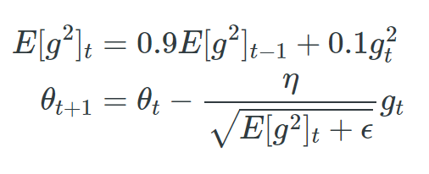

*Figure 16: RMSprop function [29]*

There is a division of the learning rate with an exponential decaying average of squared gradients by RMSprop. It is recommended that γ be set to 0.9, with 0.001 as an acceptable default value for the learning rate η [29].

Adam stands for Adaptive Moment Estimation, is one of the most favored and usually utilized GD optimization methods, which is a calculating manner for adaptive learning rates for every single parameter, stores the median decay of preceding gradients, comparable with momentum as well as the median of decaying in preceding squared gradients, similar to RMS-Prop and AdaDelta. It incorporates the benefits of both strategies. Furthermore, Adam brings some benefits that are easy to implement, computationally efficient, using little memory requirements, converging rapidly, rectifying vanishing learning rate and high variance, but its computation is costly [28].

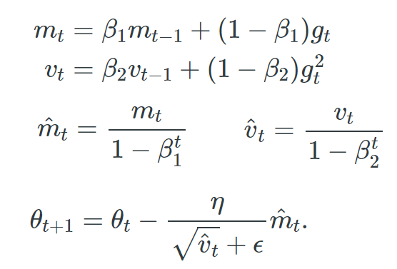

*Figure 17: Adam function [28]*

In Figure 17, m(t) and v(t) are numbers of the first moment being the average and the second moment being the non-centered variance of the gradients, respectively. There is a set of default numbers for β1 equals 0.9, β2 equals 0.999, and ϵ equals 10-8.

## Convolutional Neural Network

Convolutional Neural Networks (CNNs), like ANNs, being an encouragement from the structure of the human visual cortex [8]. CNNs, which are a type of NN typically utilized for duties in CV in deep learning, having consistence of convolutional layers, pooling layers and fully connected layers. These networks are identical to traditional NNs, except that instead of generic matrix multiplication, a kernel of convolution is utilized in a or several layers of them [3]. These networks have the role of image reduction becoming another easier formation for processing, which help not disappearing critical features to achieve an acceptable prediction. Moreover, images are tensors in 3 dimensions of width, height, channels, and CNNs have ability to take the tensor as an input, identify which image characteristics or features are essential for classification and its output [1, 7].

Therefore, the basic structure of a Convolutional Network in order starting from a Convolutional Layer or so-called convolution process (do not count the initial input layer), has the effect of picking out the 3-dimensional specificities of the image input. Particularly, the features of the input original image are passed through the “convolutional layer”, at which there is a mechanism built up by matrix multiplication between the input image known as a matrix and one or more matrices with a certain size (usually smaller than the input matrix) being called “filters”, this matrix multiplication will be shifted by rows and columns with a certain rule that will give generate one or more new matrices based on the number of filter layers, the product from this process is called feature maps which contain the attributes of the original image’s input.

The pooling layer helps the network synthesize the features of the image in a deeply specific way (max pooling) or more objectively general (average pooling or mean pooling) from the preceding layer’s output. Next, the size of the image has been significantly reduced that is very meaningful for memory in process of training model. Although the dimensions are decreased, the number of channels or feature maps are still kept unchanged. So, this process is as a composition of a reduction for the size of the image’s input feature in length and width as well as a reduction of the number of learnable parameters. At last, when the input size has been reduced to a reasonable value, the 3-dimensional image will be converted to dimensional vector or known as "flatten layer", at which this process is generally implemented as a Fully Connected Layer, its units will correspond to a number of classes that defined for the network before, relied on specific AF, the final network’s output will produce a specific final result in range of the classes.

In general, using CNNs because of their capacity to learn translation-invariant patterns as well as spatial hierarchies utilizing appropriate filters. The invariant patterns of learning translation mean to be once a pattern is learned in an area of a provided image, and the network will have an ability of recognizing it anywhere in image. This improves image processing productivity by requiring less samples of training for learning generalizable depictions [1].

Hierarchies by space show that earlier layers in the network can learn tiny patterns of local and grow up to bigger patterns composed of these tiny patterns of next layers, which also improves the network's potentiality of learning complicated and abstract concepts of visualization. In addition, this also allows these networks to deliver class predictions with far higher accuracy than vectorization of a complicated image relied on reliance of pixel throughout Therefore, CNNs have to be used for any image classification task so as to pursue these crucial properties and correlations between features [1].

### Convolution Layer

Convolution is an operation that produces a new function by combining two functions of an argument with real value. Let s(t) is the output estimate function relied on time t, and x(a) is the age-based function off input position, and w(a) is a function of the weight prioritizing measurements in recent. This is the universal formula for convolution utilizing this defined function:

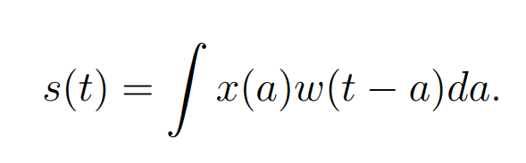

*Figure 18: Convolution Function.*

In detail, the input is the function x(a), the kernel is the weighting function w(a), and the output s(t) plays a role of feature map in the CNN. the CNNs use convolutions that are operated over two-dimensional tensors being made up of the input images' width, height and channels of color. These techniques take out patches and alter the input for building a feature map with varied depth. One of the two critical criteria for defining these convolutions is the size of these extracted patches. The depth of the output feature map is the second parameter to consider. This is the number of filters built relied on the layer that is able to encode diverse features of the input data.

Two – dimensional convolutions are computed by moving a window with squared-shape of defined width and height across all of the input feature map's pixels, which connect to each local region or receptive field of the image corresponding to the size of the applied filters. For images, the input feature map has three dimensions which are width, height and channels for color, commonly representing for red, green, and blue. When these feature maps perform 2D convolution, there is a creation of two-dimensional patches with features encompassing. Next, these patches are turned into a one-dimensional vector reflecting the output depth via a convolution kernel. After that, the vectors are spatially reassembled into an output map with two-dimensional being equivalent with all points in input map. This progress of convolution is depicted in the Figure 19 below.

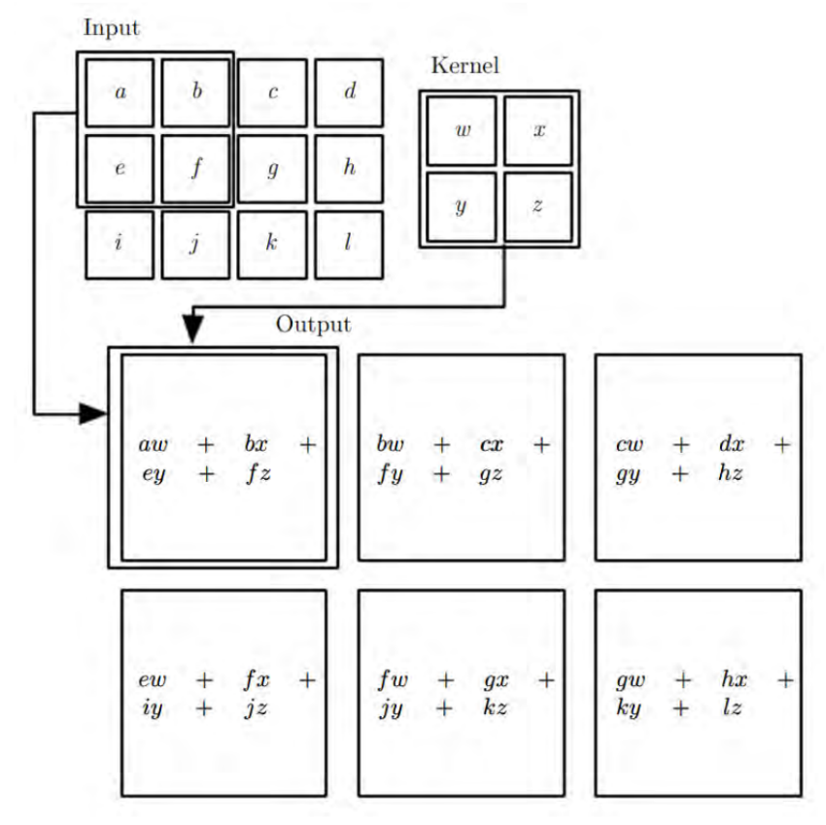

*Figure 19: Feature maps are computed by stride mechanism of convolution process.*

In other words, a feature map is a convolutional layer’s output, which is typically a three-dimensional tensor with dimensions width, height, and depth. To process inputs or feature maps, the convolutional layer employs a filter, similar to the filtering procedure in picture pre-processing. The primary distinction is that in standard image pre-processing, the filter weights (values) are hand-crafted, whereas in CNNs, during training, these weights are learnt. Alternatively, the receptive field in the input feature map corresponds to a convolutional layer’s output, and the size of the receptive field is governed by expansion and the kernel size. It is not essential to flatten images while using CNNs. However, flattening is required to feed the features maps, being the outputs of convolutional layers, to the fully connected layers. Fully connected layers are the same as the ANNs mentioned above, however ANN is a catch-all term for all artificial neural networks, including CNNs. Fully connected layers understand the linear and non-linear correlations between extracting features and classifying each sample into many abstract classes. Figure 20 shows a simple CNN architecture.

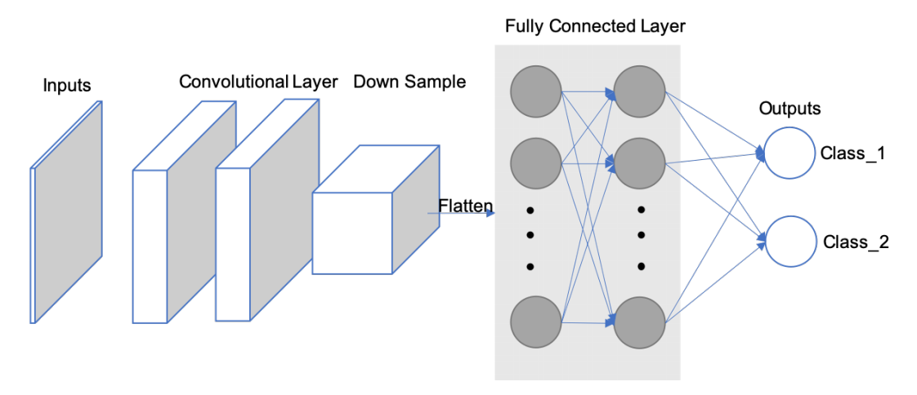

*Figure 20: CNN Architecture.*

There is a navigation from hyper-parameters imposing to the output volume's size, they are stride, depth, and zero - padding.

The first component of the output volume decision is depth, which is how many filters can be utilized. Each of them learns to search for several distinctness from the input. If the earliest Convolutional Layer receives the image in raw as an input, distinct neurons along the dimension of depth are able to fire in the attendance of edges with different orientations or color droplets. A column of depth is a group of neurons being all staring at the same region of the input [9].

Stride aids in picture and video data compression tuning. The stride of the convolution is a characteristic which can contribute to a different output size in CNNs, which has an ability of making contribution to a divergent output size in CNNs, which is a parameter of convolutional operation defining the distance among the patches acquired from the feature map's input. With value is 2 for a stride, the output feature map in width and height is down-sampled via a factor of two with no padding. For example, if the stride is set to 1 in a NN, step by step, the filter will make a reflection onto the matrix of input, which move one pixel or one unit at a time from left to right in the row till the end of horizontal point and top to bottom in the column at the end of the matrix. Because the size of the filter influences the encoded output volume, stride is frequently a positive integer rather than a fraction or decimal.

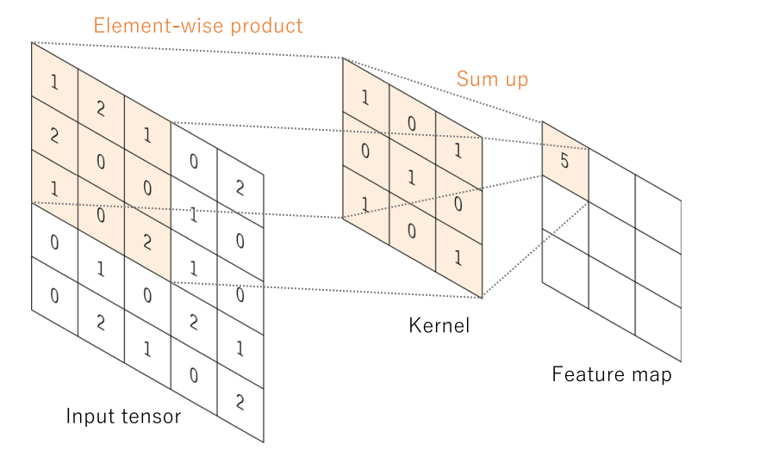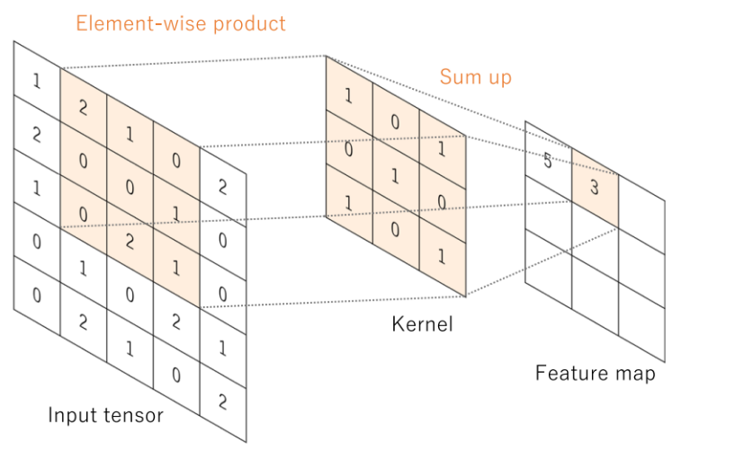

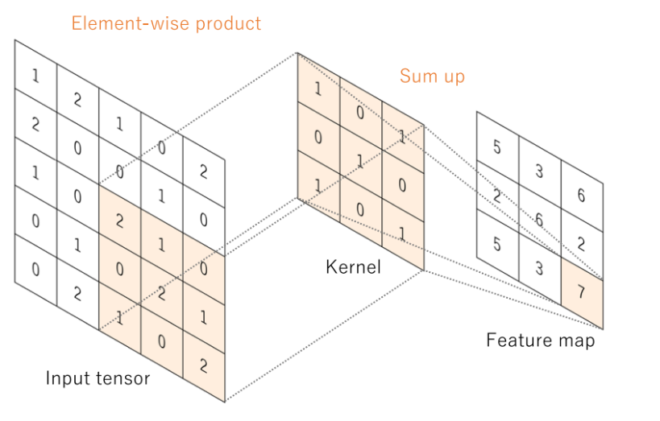

*Figure 21: Generating feature map process.*

It is sometimes useful for padding the input volume by the around border with zero value. This padding with size of zero is a hyperparameter. The great thing about zero padding, which allows to tweak the output volumes' size by space, most typically using it for precisely preserving the input volume's size by space so as to be same of the input and output width and height [9].

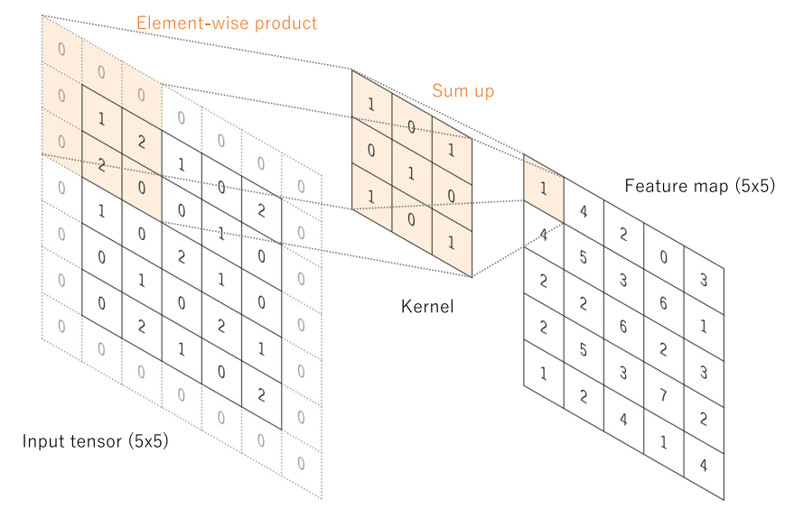

*Figure 22: Generating feature map process with zero-padding.*

Combination of these components will give out the formula for calculating the size of Convolutional layer:



*Figure 23: The formula of output size of Convolutional layer.*

The dimension by space of the output volume may be calculated like a function of the input volume size (N) which represents for the dimension by width and height of input image, the receptive field size of the Convolutional Layer neurons (F) as the dimension of filter by width and height, the zero-padding number placed the border for input image (P), the positive integer number of strides with which they are applied (S), and the number of filter (C’).

The results of an operation in linear such as convolution, which is subsequently processed by a non-linear AF. Despite being preceding utilized smooth non-linear functions like a function of sigmoid or tanh because of being mathematical representations of biological neuron behavior, the ReLU is now the most popular non-linear AF in utilization, simply computing the function in form f(x) = max (0, x)

In convolutional neural networks, rectified linear units (ReLUs) provide three key advantages:

* + The ReLUs efficiently transmit the gradient, reducing the risk of a vanishing gradient problem, which is prevalent in deep neural architectures.
  + The ReLUs set negative values to zero, so solving the problem of cancellation and resulting in a much sparser activation volume at its output. Sparsity is helpful for a variety of reasons; However, it is most commonly used to supply robustness to tiny adjustments in input such as noise.
  + The ReLUs that including just simple computations (primarily comparisons) and are thus substantially more efficient to implement in convolutional neural networks.

### Pooling Layer

There are also pooling layers between convolutional layers. They are used to down sample the feature maps and make a decrement of parameter number. There is an essential of a huge number of parameters for the following layers after extraction of feature, the reason is having an existence of exponential increment of the determination in depth by the number of the following layers' channels. That makes an increasing in parameter number and the amount of the neural network's computation. Therefore, to reduce the computational load we will need to reduce the dimensions of the input matrix block or reduce the number of layer units. Therefore, needing a reduction of input matrix block's dimensions or a reduction of the layer unit number to pull down the computational load. Since every individual unit will present for a result of apply a filter for finding out a specific feature, the cutback for unit number will be impossible. Another key point, finding a value of representation for every single region by space passing through by the filter to cut down the size of input matrix block, which only have ability of reducing the image size, but not able to change the image's main contours. As a consequence, the process of reducing a matrix is applied.

Average-pooling and max-pooling are the two most popularly utilized types of pooling layers helping make this reduction purpose. As the suggestion of their names, average-pooling takes out mean of the feature map values corresponding to a kernel size. Besides, max-pooling calculates the maximum value in neighborhood corresponding to the kernel size position on the feature map. Both of them travel through the whole feature map by a stride size without overlapping local region position. In addition, the pooling layers do not have any parameters which need to be learned during training and the stride in the convolutional layer is able to also be used to replace the pooling layers. Figure 24 shows the difference between these two pooling types.

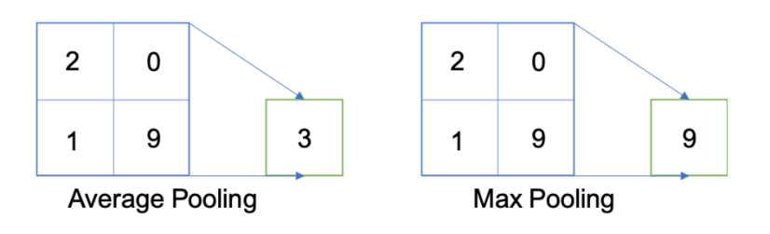

*Figure 24: Average (Mean) and Max Pooling Layer.*

### Batch Normalization (BN)

Another critical component of a CNN architecture is batch normalization. Although this is not a required component in CNN, it is a relatively important component with many benefits for training the model to reach the best results. BN allows faster training and stabilization of deep neural networks by stabilizing the distribution of layer inputs during training. This approach mainly involves Internal Covariate Shift (ICS). To improve model training, it is important to reduce ICS by controlling the means and variances of the input data layers. In detail, BN normalizes the feature maps at a convolutional layer’s output in the same way which it normalizes the input pictures. BN makes subtracts the batch mean and divides the feature map values by the batch standard deviation for ensuring that the feature maps’ distribution is the same. As a result, BN lowers value shift in hidden layers and BN allows to obtain an additional flexibility in the initialization of kernel weights. Furthermore, because of guarantee of BN which activation does not diverge to very large values, greater learning rates can be employed. In addition, BN is quite similar to a dropout layer which also has some regularization effects, because of adding noise to the feature maps. During training and evaluation, both the BN and dropout layers will behave differently.

When we would like the “function of probability density” (FPD) of the model to be closest the true real distribution of data as possible in deep learning. Unfortunately, in fact that we only have a narrow amount of training data at our disposal. As a result, the goal is to get the FPD of the model as near to the FPD of the train as possible by training on a dataset that replicates the domain of application in the real-world. A sufficiently big training dataset is required to get improved representation. When the set of training data is insufficiently huge, there will be a significant difference in the error between the FPD of real and the FPD of train.

In other expressions, even if we produce a model FPD that is very close to the FPD of the train, it will not perform with the FPD of test skillfully, being a sample of the FPD of the real. This is referred to as the overfitting problem. Overfitting occurs when a model produces a good performance in train data set and a very bad performance in test data set. However, the model is not overfitted when performing impressive in training and a bit worse in testing. Dropout layer is applied to stay away from overfitting by randomly selecting some neurons to brush aside throughout the training process. A dropped-out node's incoming and outgoing edges are also eliminated. Thus, dropout not only reduces the problem of overfitting, but it also simultaneously speeds up training by eliminating training with all nodes.

### Fully Connected Layer

Typically, there is an applying of AF at the last connected layer that is different from the others. Each job necessitates the selection of an appropriate activation function. An SF is utilized as an AF in the multiclass classification job to work as a normalization for real values of output from the ultimate "fully connected layer" to probabilities of goal class, in which every single value is a real number in range from 0 to 1 and these values will be made a sum to 1. Typical final layer AF selections for several sorts of jobs.

In addition, the majority of the trainable parameters are located in fully connected layers in CNN. Fully connected layers can give out outputs that are categories for image classification or localization via bounding boxes [11]. Convolutional layer work can also be used as fully connected layers to execute the same duty more efficiently. Instead of a class, the achievement of an image segmentation job is a mask with the same resolution as the input pictures. We may use a 1x1 kernel as the output layer to reduce the depth to the same level as the target classes [10], giving the model pixel-wise classification capability.

Training a CNN consists of two steps: forward and backward. We feed the CNN with input information flow in the forward. To acquire the input for the following layer, feature maps are generated in each layer with predefined weights and biases. A loss value will be computed at the output layer by applying a function of loss for the difference between the calculated output and the ground truth. The chain rule is utilized in the backward step to find out the gradients of loss value for each trainable parameter. After that, the gradients are utilized to adjust each parameter for the following iteration. This type of update is what allows CNNs to “learn”.

After processing enough iterations, at which the loss value converges to an acceptable small number that means it is approximately close to zero, the training process can be terminated. The loss function computes the difference or error between the outputs and the ground truth. Minimizing loss implies minimizing the difference between model’s function of probability density and train one when the loss function is applied as a guide. Moreover, the loss function will change depending on the application and objective. Because of its ability of quantify the similarity/difference between two distributions, cross-entropy is a widely used loss function.

Otherwise, there are several optimizer options to help you decide how to update the network parameters. Adam and Stochastic Gradient Descent (SGD) are two options. In general, SGD will produce better results while learning at a slow pace. It will take several iterations to achieve a satisfactory outcome. SGD has a fixed learning rate that does not vary during training. Adam, on the other hand, converges quicker since it employs a vector of learning rates that are adjusted as learning continues during training progresses. They will be mentioned more detail in the next sections of Optimizer.

## Residual Network (ResNet)

ResNet, an abbreviation for Residual Network, is a form of NN introduced in 2015 by Kaiming He, Xiangyu Zhang, Shaoqing Ren, and Jian Sun in their paper "Deep Residual Learning for Image Recognition". The ResNet models were immensely successful with winning first place in the competition of the ILSVRC 2015 for classification with a top-5 error proportion of 3.57 percentage (An ensemble model), as well as first place in the competitions of ILSVRC and COCO 2015 in ImageNet both detection and localization, Coco detection, and Coco segmentation [20]. Furthermore, ResNet-101 was used to replace VGG-16 layers in Faster R-CNN. They discovered a substantial boost with a proportion of 28 percentage. ResNet was developed because of the vanishing or exploding gradient issue on some state of the arts model architectures at that time.

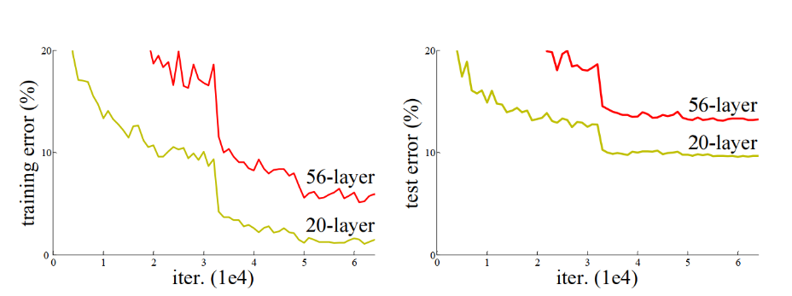

*Figure 25: Performance of 20 layers and 50 layers plain networks on CIFAR-10 [20].*

Before the ResNet, with the advent of neural networks deeper and deeper by a common argument, which is "go deeper", growing up the depth of the network will be an improvement for the quality of the network. Based on that, several new DNN architectures have been born such as AlexNet, GoogleNet or VGG, which apply the mechanism to increase the number of layers or number of layer's group. Because these added layers are able to solve complicated issues more efficiently as the non-identical layers could be trained for various duties to get high results of accuracy. Additionally, the number of stacked layers can enrich the features of the model. However, with an increasing number of layers of complexity in deeper CNNs, a new trouble has also emerged called vanishing gradients. In specific, as deeper networks may begin to converge, the accuracy of the network gradually saturates to a certain threshold and then slowly moves down during backpropagation step, and higher error increases may occur. This issue goes against the purpose of reducing error and increasing accuracy during network model training. In other words, the values ​​go through the gradient step that are chain-rule by the calculation of partial derivatives method, which will quickly return a very small result that approaches 0 after several chain-rule applications [22]. It will lead the learning of the network stopped soon, so this backpropagation will not be executed in previous layers, in this case, it may be stopped at an unknown hidden layer. This problem of training very deep networks has been alleviated with these ResNets which are made up from Residual Blocks (RBs).

### Residual Blocks (RBs)

ResNet takes advantages of using RBs to increase model accuracy. The strength of this form of neural network is the concept of "skip connections" or skip paths, which is at the heart of the RBs. There are two ways for the skip connections to work. At first, they address the issue of vanishing gradients by creating an alternate path as a shortcut for the gradient to go through. Second, they also allow the model to learn a function of identity, which assures that the model's upper levels will have a performance not being worse than the layers lays underneath.

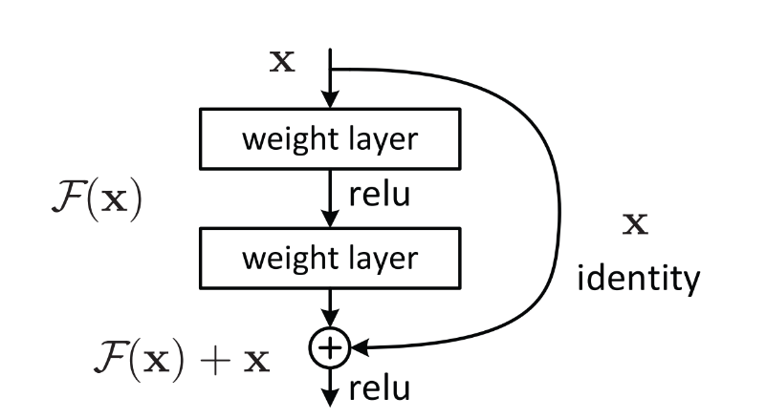

*Figure 26: Residual Block Unit with skip connection [20].*

The construction of an RB is depicted in the Figure 26. The ResNet is developed to create its stack of 2 layers being able to fit to F(x) = H(x) - x rather than training only stacked convolutional kernels have an ability to be suitable to the intended mapping. Supposing that, the original mapping has been recast as H(x) = F(x) + x [20]. They claim that optimizing the residual mapping substantially easier, which is F(x). In spite of being the optimal option of the identity in an extreme circumstance, model will give out a result in F(x) being zero. Using such a framework, networks with more than 100 layers might be trained. Besides, this method appears to have a minor flaw when there is a difference between input's dimensions and those output, which have ability to occur with pooling and convolutional layers. When the dimensions of F(x) differ from those of x, we have two options:

* To up-sample its dimensions, extra zero entries will be padded to the skip connection.
* To make the dimensions equal, the linear projection approach is utilized, which is accomplished by attaching more 1 x 1 convolutional layers to the input. In this example, the output is as follows: H(x) = F(x) + W(x). In this case, adding an extra parameter W.

In short, the RBs help the layers acquire a knowledge of identity functions substantially easier than plain networks. So that, ResNet raises up the performance of DNNs with additional neural layers while reducing the proportion of error. In other words, the skip paths combine the outputs of prior layers with the outputs of stacked layers, allowing for considerably deeper networks to be trained than previously feasible.

### ResNet Architecture

#### ResNet – 34 Architecture

The ResNet-34 was the first architecture built, which included inserting shortcut connections into a plain network to transform it into counterpart of its residual network. The plain network in this case was influenced by VGG neural networks (VGG-16, VGG-19), while the convolutional networks had 3 x 3 filters. On the other hand, ResNets have fewer filters and are less sophisticated than VGGNets. There is a comparison between the 34-layer ResNet attains 3.6 billion FLOPs of performance and larger VGG-19 with 19.6 billion FLOPs [20]. ResNet 34 takes a proportion of 18 percentage of VGG-19, thus, the VGG-19 has more filters and higher complexity than ResNet 34.

The ResNet-34 also adhered to two simple design principles that the layers must to have the same filter amounts for the same size of feature map's output, and the filter amounts is twofold if the size of feature map is cut off a half to maintain the time complexity for each layer [21]. And one more thing is 34 weighted layers being involved in it. In addition, this plain network plus shortcut connections. Despite being identical in the input and output dimensions, the identity shortcuts were employed by a direct route. There were two choices for considering when the dimensions raised up. The first one was the shortcut would continue to execute identity mapping while padding extra zero entries for an increment of dimensions. The projection shortcut could also be implemented to fit dimensions.

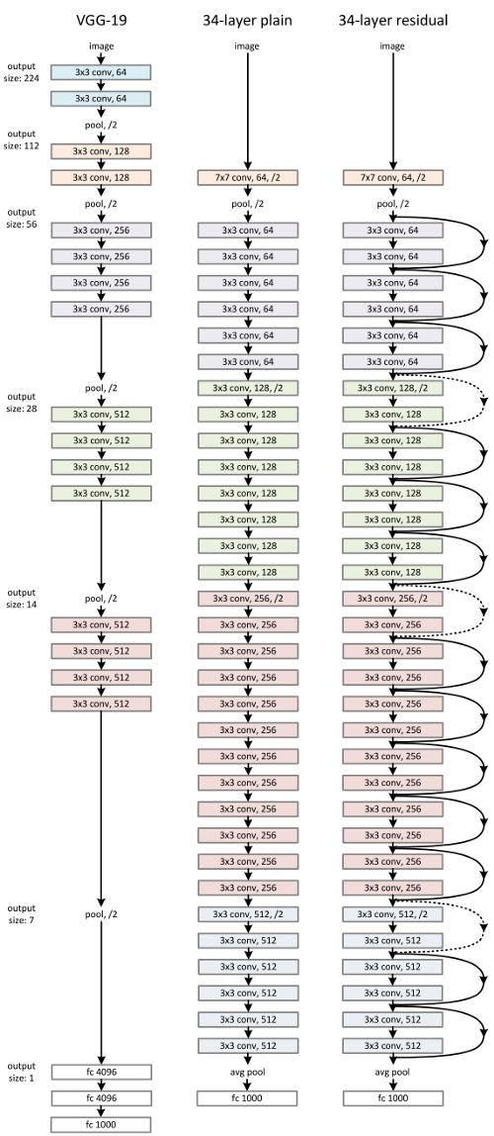

*Figure 27: VGG-19 model, 34 Plain Network, ResNet 34 [20].*

#### ResNet–50, ResNet–101, and ResNet–152 Architecture

Although the ResNet-50 architecture is based on the above model, there is one significant variation. In this situation, the RB was re-created as a design of bottleneck appearance cause of concerning about the requirement of time for training the layers. Instead of using two layers, a three-layer stack was used for building of RB. As a result, each of the ResNet-34's 2-layer blocks was taken a place of a 3-layer bottleneck block for the constructure of ResNet-50, which is as known as “Deeper Bottleneck Architecture”. This model is generally more accurate than the 34-layer ResNet model with performing of 3.8 billion FLOPS compared with 3.6 billion FLOPS [20].

Furthermore, Larger Residual Networks are the 101-layer ResNet-101 and ResNet-152, which are built with additional 3-layer blocks as well as ResNet-50 [21]. Even with an increment of network depth, the 152-layer ResNet reaches to a very high number of FLOPS, it is about 11.3 billion, and has a specifically lower complexity than VGG-16 or VGG-19 nets with the number of FLOPS about 15.3 and 19.6 billion in respective.

## EfficientNet

Following the previous success of AlexNets, GoogleNets, VGGs, ResNets, Gpipe, RCNN, or Mask RCNN with outstanding results in image recognition contests as well as the impressive accuracy in image recognition tasks bringing in reality. EfficientNet was born in 2019 by Quoc V. Le et al from GoogleBrain. Based on inspiration from the process of scaling up ConvNets, these researchers systematically studied it and came up with a completely new solution compared to the previous state of the arts solutions, which is scaling up the main component of the network model in 3 dimensions: in depth - scaling to add more layers to the model, in width - scaling to add more channels for layers, in resolution - scaling in resolution being also known as the size of the layers, feature maps, they called it the "compound scaling method"[25].

Before going into more detail about EfficientNet, we will learn about the reason why the Model Scaling definition of the previous network models are the fundamental foundation to construct the EfficientNet.

### Model Scaling

In fact, the state-of-the-arts models is built by Model scaling method, and "go deeper" is also one of this method. ResNet is able to be scaled up or down by modifying the layers of network - in depth, whereas WideResNet and MobileNets have ability to scale based on adjustment of the network's channels - in width. Besides, the network model is also widely acknowledged that larger input image sizes improve accuracy while incurring the burden of additional FLOPS [25]. Although several previous researches have proven that width and depth of network are both crucial for the power expression of the ConvNets. It is still not easy to productively scale a ConvNet for a better achievement of accuracy and efficiency.

**In Depth**: Many ConvNets, including ResNet and Inception Net, scale network depth in this manner. The assumption is that deeper ConvNet is capable to capture more affluent and more complicated characteristics of image while also generalizing successfully on new tasks. However, because of the vanishing gradient problem, deeper networks are harder to train. In spite of having numerous approaches as ResNet-skip connections and batch normalization to mitigate the training issue, the accuracy gain of very deep networks will drop, for example: Despite having so many more layers than ResNet-101, ResNet-1000 has equal accuracy [23].

**In Width**: For small scale models like MobileNet, MobileNetv2, and MnasNet, scaling network width is widely applied. Wide residual networks of Zagoruyko and Komodakis in 2016 explored how wider networks can take more fine-grained features and are easier for training [25]. On the other hand, outstandingly wide but shallow networks, having a difficulty in catching the features in higher level. Therefore, when networks expand substantially wider with bigger channels, the accuracy quickly saturates [23].

**In Resolution**: ConvNets may be able to catch more fine-grained patterns with higher resolution input photos. Early beginning with 224x224 with ConvNets, later ConvNets often employ 299x299 or 331x331. And in 480x480 resolution [23], GPipe just achieved state-of-the-art accuracy of ImageNet. In object detection ConvNets, higher resolutions, such as 600x600, are also commonly employed [23].

So, although the accuracy of the model will be enhanced when making a scale up at any single network’s dimension in width, depth, or resolution, the gain of accuracy reduces in larger models.

### Compound Scaling Method – EfficientNet

Based on the above 3 options of Model scaling method, the EfficientNet’s researchers have come up with the compound scaling method which is a uniform combination of 3-dimensional expansion in the width, depth and resolution of the network, with a set of the ratio is fixed, this aims to create a balance in the dimensions of all 3 dimensions [25].

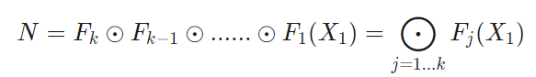

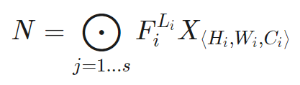

*Figure 28: Common ConvNets equation [25].*

The formula in Figure 28 presents for commonly structure of network model base on ConvNets layer, the ConvNets layer i was defined as an equation Yi = Fi (Xi), where Fi is an operator, Yi is an output of tensor, FiLi presents Fi layer iterating Li times at i state, Xi is tensor input, spatial dimensions are Hi and Wi as width and height, and the Ci represents for the number of channels, all of these things make a combination for a list of layers. In fact, the Convnet layers are divided into a plenty of stages and all the layers in each state have the same architecture such as ResNet [25]. EfficentNet expands three dimensions of width (Ci), length (Li), and/or resolution (Wi, Hi), this action makes no change for Fi. Based on fixing Fi, issue of the design for limitations of new resource will be simplified by model scaling, however, there is an existing of a huge space of design for discovering various of these 3 dimensions in every single layer. So, there is a limitation that all layers have to be scaled consistently with unchanged ratio to get a further reduction of design space. It serves for purpose of maximizing the model accuracy in any case of having any limitation of provided resource. [25]. Formula below shows the optimal solution of the model scaling, where (w, d, r) are coefficients for purpose of scaling up network’s dimension in width, depth, and resolution. F^i, L^i, H^i, W^i, C^i are predefined parameters in baseline network.

The model can achieve better accuracy and efficiency, more specifically this ratio is followed by this principle:

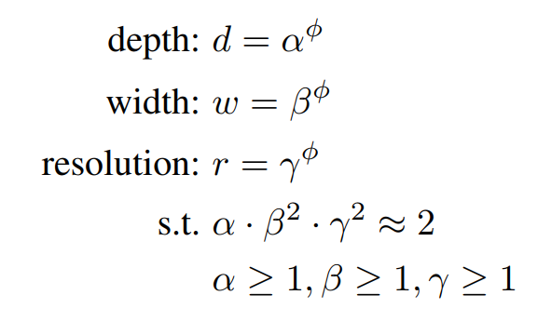

*Figure 29: The setting of coefficient values in compound scaling method [25].*

Where α, β, γ are invariable numbers having potentiality of being affirmative by a tiny search by grid. Visionally, φ (Phi) is a coefficient able to adjust and increase the number of available resources for model scaling by user's designation, while α, β, γ are respective to the size of width, depth and resolution that are additional to the network [25]. The FLOPS of a normal convolution operation is proportional to d, w2, r2, i.e., increasing network depth twice, will make a double increment of FLOPS too, however, if there is a double gaining of network width or resolution, it will be a cause of a quad-increment for FLOPS [25]. That said, convolution operations often prevail over the cost of reckoning in ConvNets, when making a scale for a ConvNet with the above equation, it will nearly improve overall FLOPS by (α · β2 · γ2) φ. And the default value of equation was set: α · β2 · γ2 ≈ 2 in order to be with any new φ, the total FLOPS will get an approximate increment of 2φ.

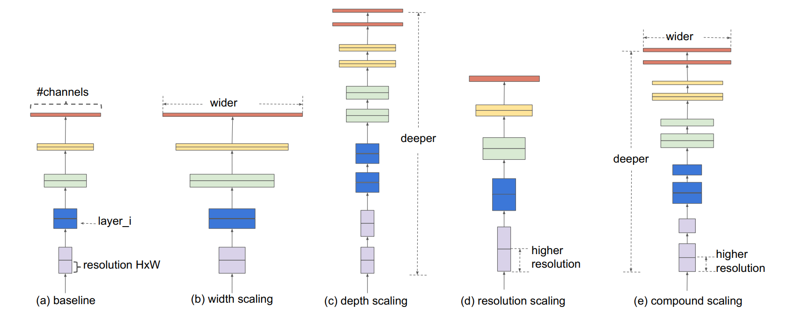

*Figure 30: Model Scaling: (a) baseline network; (b) – (d): the networks only scale up a dimension in width, depth, or resolution; (e): method of compound scaling network has a scaling uniform of 3 dimensions with a fixed ratio [25].*

### EfficientNet Architecture

Because model scaling did not modify layer operators F^i of baseline network and had a valuable baseline network is also essential. The EfficientNet was built based on existing ConvNets with scaling method, in specific, they are MobileNet and ResNet, the mechanism is with a manipulation of a multi-objective neural architecture search, it made an optimization in both accuracy and FLOPS.

Indeed, manipulating ACC(m) × [F LOPS(m)=T] w as a goal of optimization, where ACC(m) plays the accuracy, FLOPS(m) play FLOPS of model m, T presents the target FLOPS and w = -0.07 stands for a hyperparameter for adjusting the exchange between accuracy and FLOPS [25]. This compound scaling method was applied with two steps:

* Firstly, there is a fixed φ = 1, assumption of having an availability of double resources and more, then making a tiny grid searching of α, β, γ relied on Equation 2 and Equation 3. Particularly, finding the best values for EfficientNet-B0 are α = 1:2, β = 1:1, γ = 1:15, under fixed value of α · β2 · γ2 ≈ 2.
* Secondly, α, β, γ will be fixed as constants and expanded baseline network by different φ utilizing Equation 3 for achieving EfficientNet-B1 to B7.

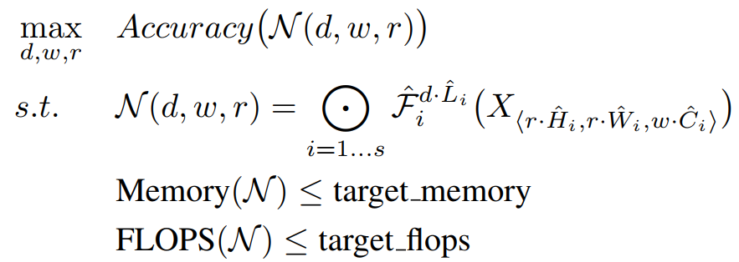

*Figure 31: Optimal formula of scaling up method [25].*

Outstandingly, this strategy is feasible to attain even higher performance by directly looking for α, β, γ from a huge model, however the cost for searching becomes extremely expensive for more huge models. This method overcomes this problem by conducting a single search on the tiny baseline network at first step and then utilizing the identical coefficients of expanding for all other models at second step [25].

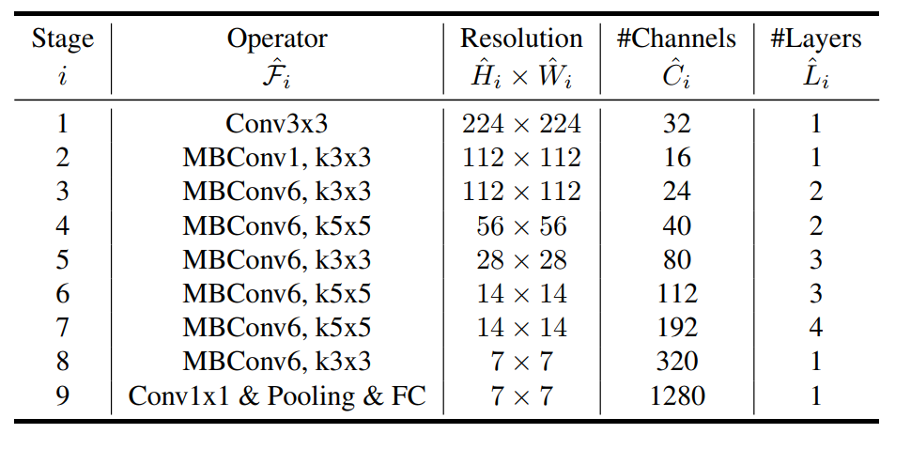

*Figure 32: Optimal formula of scaling up method [25].*

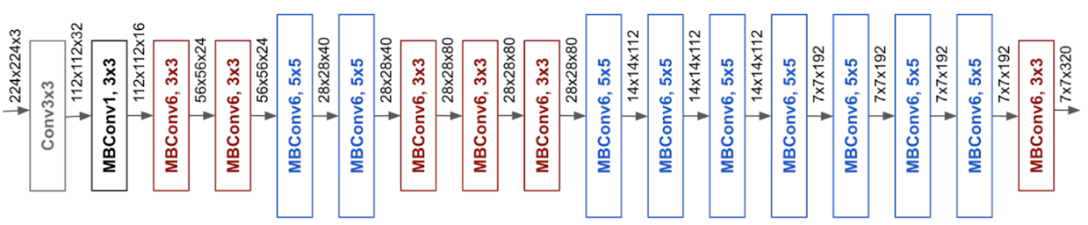

*Figure 33: Efficient Net – B0 [25].*

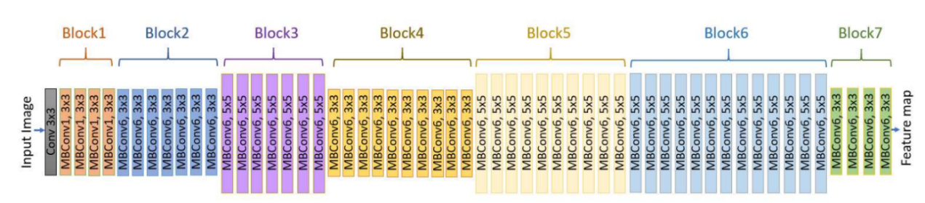

*Figure 34: Efficient Net – B7 [31].*

As a result, EfficientNets give out an outstanding performance to other ConvNets. Specifically, EfficientNet-B7 got over the best existing accuracy of GPipe with utilizing 8.4x less parameters than and executing 6.1x faster on inference [24], it was about 66 million parameters and 37 billion FLOPS that reach to a proportion of 84.3 percentage of the accuracy. Adding, there was a comparison of ResNet-50 and EfficientNet-B4 that made an improvement of the peak of accuracy from 76.3 percent to 83.0 percent, increasing about 6.7 percent with similar FLOPS.

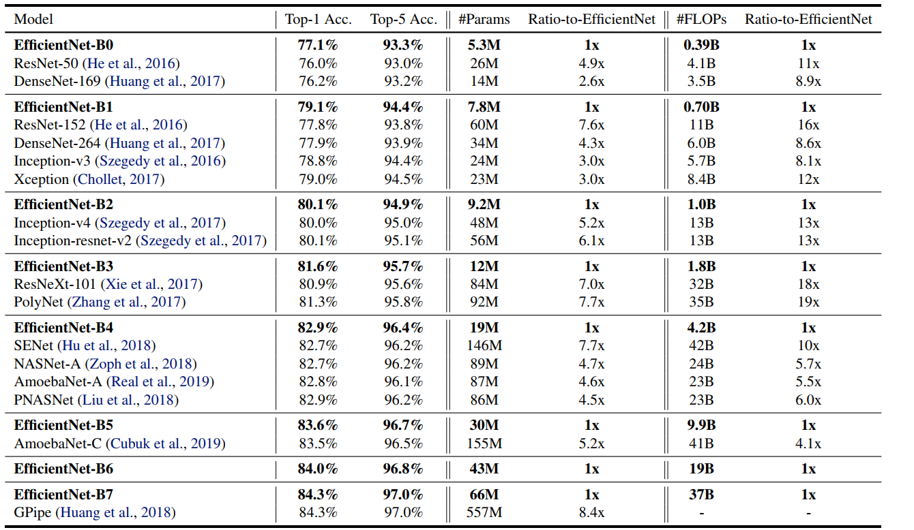

*Figure 35: EfficientNets Performance Result on ImageNet [25]*

## Fully Convolutional Networks (FCNs)

One of the turning points in the field of image detection was the introduction of the FCN, which is known as a variant of CNN for image segmentation work [10]. The FCN has a difference from ordinary CNNs in which the fully connected layers are taken over by convolution layers at the end of the network. So, there is a generation of a network making a computation of a nonlinear filter for each layer's output vectors. As a result, not only can the completed network function on an input of any size and make a production of an output with respective dimensions by space, but this allows the network for classification to generate a desiring class’s heatmap. In addition, adding layers and a spatial loss to the network results in an efficient machine for end-to-end dense learning [10]. Figure 36 shows the transformation of FCN.

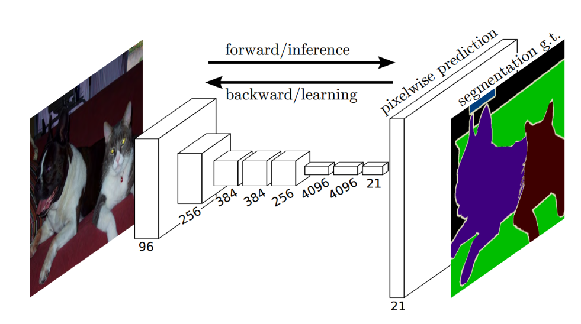

*Figure 36: Fully Convolutional Network serves for semantic segmentation tasks [10].*

The use of FCNs makes introduces allow to take multiple input image sizes, and to have a better efficiency for dense predictions of learning via in-network up-sampling [10]. Furthermore, the FCN may preserve spatial information from the input that is very important for semantic segmentation task because of involving both localization and classification for the task. Although an FCN has a potentiality for accepting any size input image, there is a decreasement of the output resolution by being applied convolutions without any padding. These were added to make filters minimal and requirements of calculation manageable. As a result, the coarse output is reduced in size by a factor equal to the pixel stride of the output unit's receptive field [10].

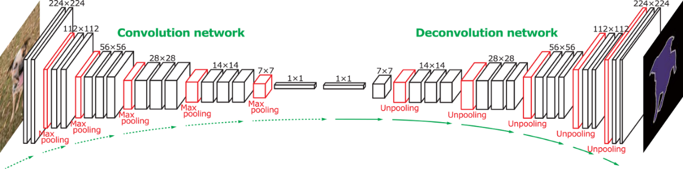

*Figure 37: Fully Convolutional Network Architecture [32]*

In other words, the FCN is divided in 2 parts that are convolution network (down-sample) as an encoder step and the following is deconvolution network (up-sample) known as decoder step, the convolution network part is very similar with casual CNN architecture so we will go deep down to up-sample part.

In Semantic Segmentation, after using the method of convoluted features extraction to decrease the input’s resolution, the following step is the job of upscaling the poor resolution turning back to the primitive resolution of the input image. Pooling is the process of converting a bunch of values to a solitary value, whereas up-sample is the process of converting a solitary value to a bunch of values and it can be named Unpooling, like Pooling, the unpooling can be carried out in a variety of ways [26].

* **Nearest Neighbour**: Choosing a value and populating it into the surrounding cells (number of cells depending on the increment in resolution), Figure 38 shows the copy process of all values in matrix 2 x 2 to every cell with size of 2×2 square in new matrix 4 x 4 [26].

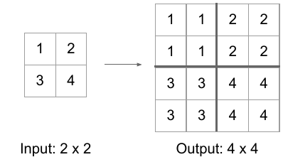

*Figure 38: Nearest Neighbour Unpooling [26].*

* **Bed of Nails**: Inserting the value in turn at a predefined cell and adding the rest with 0, the Figure 39 is an example of filling the value from the top-left cell of each 2 × 2 square in new matrix with size 4 x 4 [26].

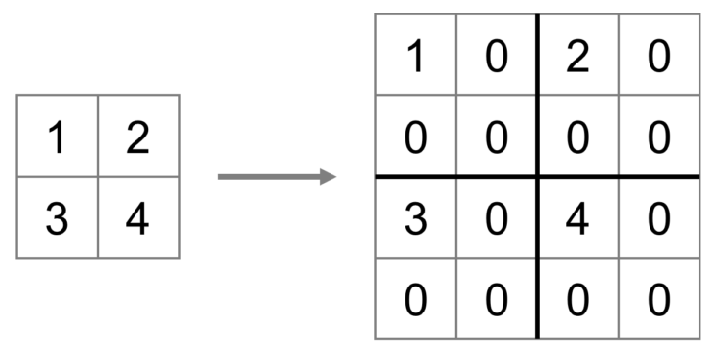

*Figure 39: Bed of Nails Unpooling [26].*

* **Max Unpooling**: In CNN, the max-pooling layer pulls the maximum values from the picture regions covered by the filter in order to down-sample the data, and the unpooling layer provides the value to the location from which the values were picked up in order to up-sample the data [26]. However, these approaches are not data-dependent, which means they are able to learn nothing from data; they are just programmed computations making them become as a specific task and costly in terms of calculation timing. The generic answer for these situations is transposed convolutions.

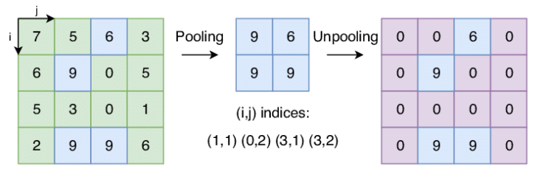

*Figure 40: Max Unpooling [26].*

Transposed Convolution, also known wrongly as Deconvolution, is the inverse action of Convolution. A transposed convolution layer, as opposed to convolution, is utilized to up-sample the decreased feature of resolution giving back to its primitive resolution. For achieving the ultimate output from the features with lower resolution, a set of strides and padding values is learned. Transposed convolution is superior than other Up-sampling techniques because of being unlike earlier techniques (Nearest Neighbor, Bed of Nails, Max Unpooling), the transposed convolution is a learnable up-sampling technique being highly efficient. The image below describes the method in a very simple way [26].

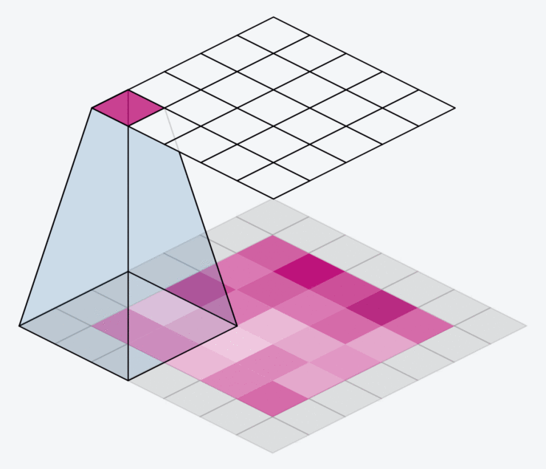

*Figure 41: Transposed Convolution [26].*

Next, because of an existing main problem with in-network down-sampling in an FCN, which is the reduction of the resolution of the input by a huge proportion, making it impossible to recreate finer features during up-sampling even with complicated techniques like Transpose Convolution. As a result of getting a coarse output. One solution is to include "skip connections" in the up-sampling from previous layers stage and then making a sum of total the two feature maps. These skip connections supply enough information to following layers to produce correct borders of segmentation. This combination of fine and coarse layers yields local forecasts with virtually accurate global (spatial) structure. The skip connection learns how to integrate coarse and fine layer information. So, there is a performance of grids with varying degrees of spatial coarseness for layers, with the intermediate convolution layers of FCN deleted for clarity [26].

## U-Net

The U-Net architecture is a variant of the FCN that is commonly used for semantic segmentation duties. Ronneberger et al. created the first U-Net architecture in 2015 to conduct picture segmentation and localization for biological applications [27]. U-Net is superior to traditional CNNs since they can give localization as well as classification in their output. In this scenario, localization implies labelling each single pixel from an image with a certain class. It is also more favorable than FCN because U-Net can function with less training photos while producing more exact segmentations. This is accomplished by constructing up-sampling layers with a huge amount of feature channels allowing context information to be propagated to layers having better resolution. Additionally, the segmentation networks of U-Net are the most appropriate for this application because of being the most easily scalable and sizeable FCN. Specially, they can keep away from a compromise between contextual information and localization, furthermore, they are frequently employed in cutting-edge semantic segmentation approaches [27].

### U-Net Architecture

The U-Net architecture is made up of a route of contraction at the input and a route of expansion at the output. Ronneburger's paper introduces the basic architecture of this network, the first route is the route of contraction, also known as the encoder path being essentially a stack of CNN components such as convolution, activation, and pooling layers, that are designed to take the context from the input image. The encoder output is produced smaller than the input, which is gradually expanded in the route of expansion. With transposed convolutions, the route of expansion has another name is decoder path which allows for exact localization. Through a series of up-convolutions and concatenation with appropriate feature maps belonging to the contracting path, the expansion pathway integrates high level features with spatial information. The architecture is depicted in Figure 42 [27].

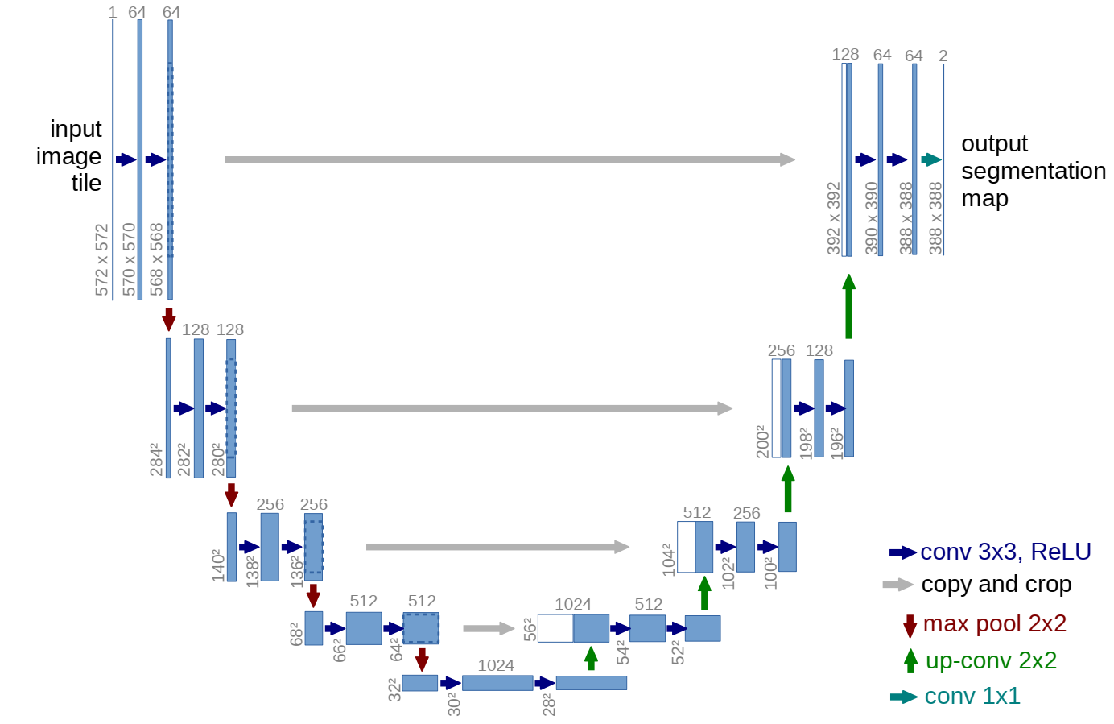

*Figure 42: U-Net Architecture (Blue box presents for a multi-channel feature map. The number of channels is indicated on the box's top. The x-y size is specified at the box's lower left side. White boxes represent feature maps that have been replicated. The arrows represent the various operations) [27].*

The encoder route of U-Net is typical CNN design, including recurring 3x3 convolutions and operations of max pooling with stride 2 for down-sampling which double amount of feature channels before appearing of up-sampling the feature map and performing a 2x2 convolution on the expanding route. In detail, these actions remove the feature channels amount in a half before concatenating them with the feature map being cropped from the route of contraction, this concatenation of the U-Net is the different point with the skip connection of FCN. After that, an extra convolution layer is added to map every single feature vector to expected number of classes [27]. The U-Net can collect image context by employing the contracting route, on the other side, the symmetric expanding route allows for exact localization. By integrating the characteristics with high resolution which come from the contracting path being up-sampled output, localization is activated. Added, the propagation of context information to the layers with higher resolution is allowed by the model's up-sampling section with a huge amount of feature channels [27].

Based on the feature maps with low level from the encoder contain more spatial information which is helpful to the analysis of complicated scenes containing multiple objects and their relative configurations, there is a combination of the feature maps at intermediate low level from EfficientNet or ResNet and the feature maps at intermediate high level from U-Net decoder. The network is able to transfer information of context to layers supplying higher resolution due to the huge amount of feature channels in the up-sampling section. Because of the symmetric characteristics in conventional U-Net. In my work, I have tried to use EfficientNets and ResNets as the encoders in contraction route instead of regular set of convolution layers. The decoder module is like the primordial U-Net. The detailed implementation for the combination of these architectures will be mentioned at the following section named “implementation”.

# Implementation

## Dataset – Image Processing

As I mentioned in the previous section, this thesis I used the dataset provided by Severstal, it is a dataset about images of steel containing defects, specifically here there are 4 types of defects, set of the data is divided into 2 main parts including images for train set and test set, and csv files containing content about pre-classification of defects on each image. Specifically, the two image folders of train set and test set are RGB images with 1600 x 256 pixels in size, they are both photos of manufactured steel and the content of the defects on them is not the same, most of them contain 1 type of defect, and a small part contains 2 types of defects. The total of image number in the data set is more than 12k5 records, while the images in the test set are more than 5k5 records. Besides, the csv file is a file that summarizes the information of the image data file, more specifically, in the data set provided by the provider, there are 2 csv files, 1 train.csv file carries the information of the train set including the train set. includes columns of information about file name (ImageId), type of defect (ClassId), pixels on image are defects (EncodedPixels), while the remaining csv file has the same structure but no information about EncodedPixels and the ClassId in the test set from the provider. Therefore, the requirement here is to create a model relied on the train set for the purpose of detecting defects on the test set without given ground-truth masks to verify.

EncodedPixels is an encoder method that minimizes the amount of information and memory size of pixel information containing defects in an image. Since an RGB image is essentially formed by 3 matrices stacked on top of each other in layers or channels, and the values ​​in each matrix represent each pixel on the image, and each value ​​has specific index certainly, so the provider encoded defect information based on starting position of pixels and run length based on these matrices, which has format [pixel index] [run length] e.g., 10 25 100 200, it means there are 2 defects on this image, which runs from 10th pixel to 35th pixel (10 + 25) and the second one is from 100th to 300th (100 + 200).

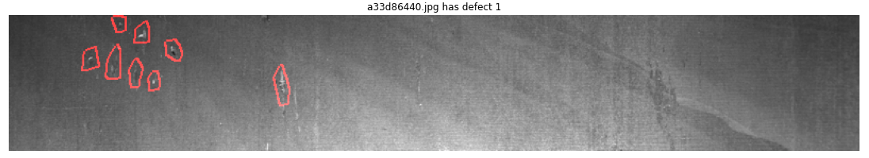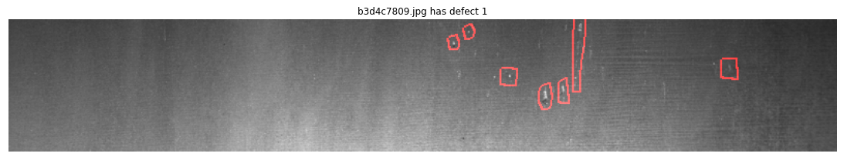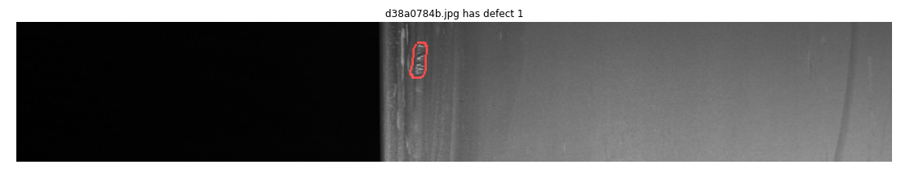*Figure 43: Defect type 1 with red border*

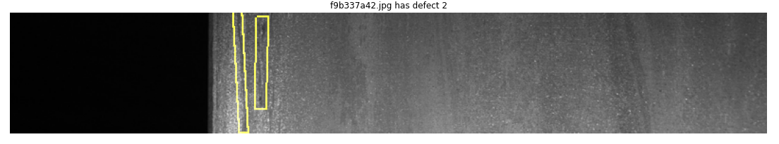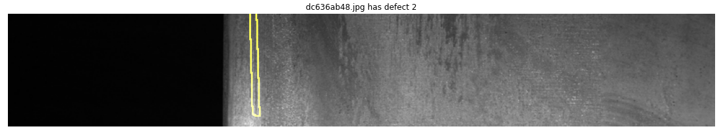*Figure 44: Defect type 2 with yellow border*

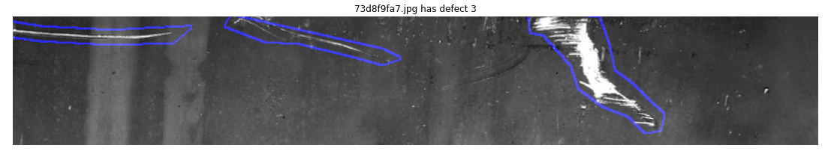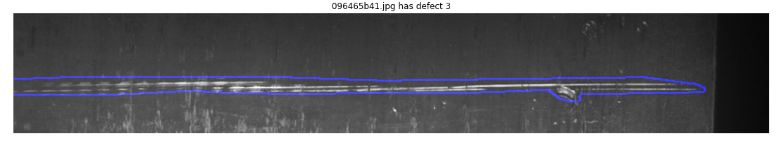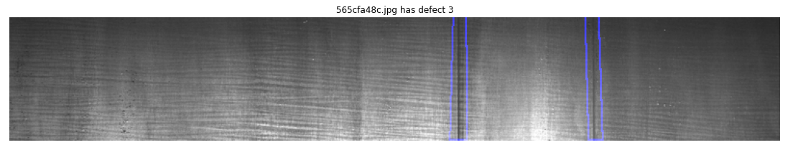*Figure 45: Defect type 3 with blue border*

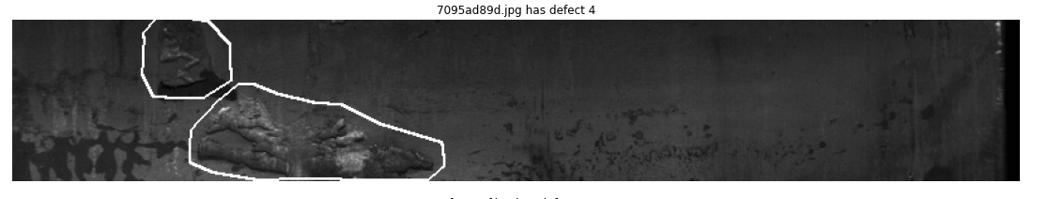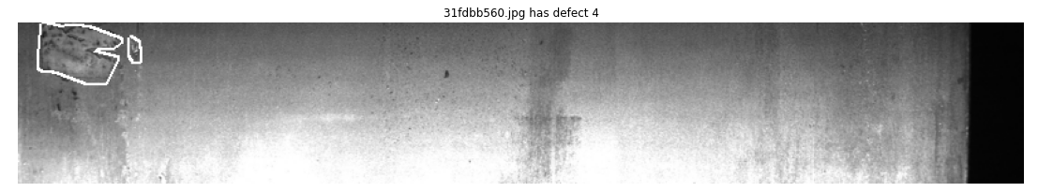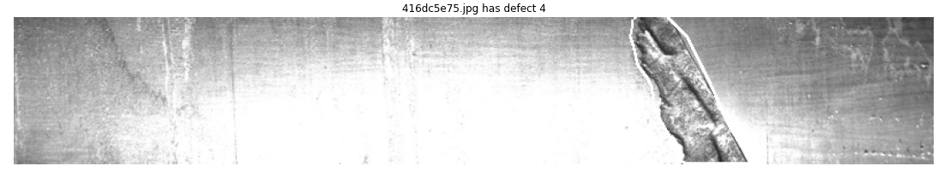*Figure 46: Defect type 4 with white border*

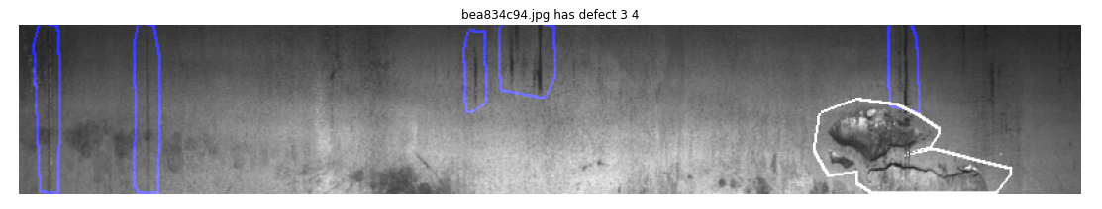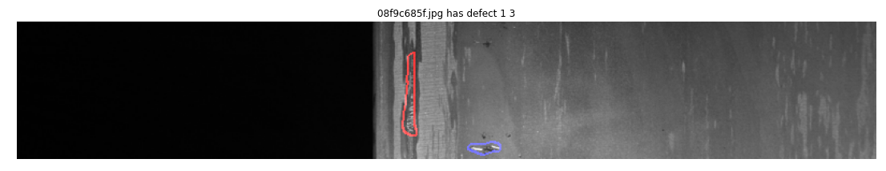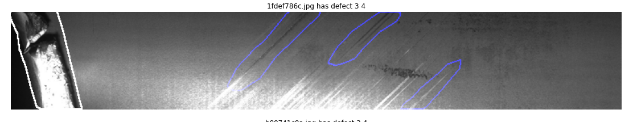*Figure 47: Image with multiple defect types*

### Data Augmentation

Train set with more than 12k5 records, but in reality, the number of defects is not balanced and the number of records with defects in the csv file is just over 6k6. In this data set, the number of type 3 defects accounts for the majority compared to other types of defects, and type 2 defects account for the smallest number in the data set, specifically, in total counting of both single and multiple defects on image, type 1 defects account for 12.6% with 897 records, type 2 accounted for 3.5% with 247 records, type 3 accounted for 72.6% of 5150 records, and type 4 accounted for 11.3% of 801 records. That is reflected in Figure 48.

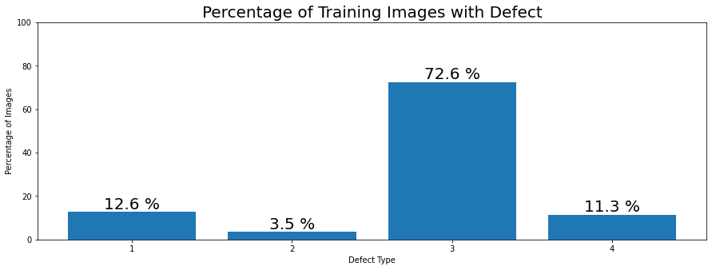

*Figure 48: Percentage of defect types include in train data*

For that reason, I applied data augmentation method to be able to help the amount of data types of defects become an equilibrium. Because, when the labels in the data for training model are not balanced, they will have a great influence on the accuracy of the model, in this case it will detect and predict defect type 3 very well, and so bad at defect type 2, and there is a relative level in the other two categories. Therefore, balancing the data is a very necessary job to improve the quality of the model.

In detail, with a smaller number in categories 1, 2, 4 I used the method of rotating 180 degrees, 10 degrees and flipping the image to increase the number of records of these types, besides, I dropped given a certain number of type 3 defects, I ended up getting a result number of defects appearing in the train set at equilibrium with 1291 records in both single and multiple defects appearing in image.

Before implementing the augmentation method, I retrieved 25 records for each single defect type and 25 image records containing multiple defect types for the test set, totaling 250 image records. The reason is that the test set provided by the supplier does not have ground-truth masks data, resulting in no data source to re-evaluate the model with the test set after conducting the training. Therefore, with these 250 records with ground-truth masks, it is easy for me to re-evaluate the model after training.

### K-fold cross-validation

With the train set balanced after the augmentation method, I applied K-fold strategy to them during the training model to increase the efficiency of the model.

This strategy divides the supplied set of training data into k disjointed subsets with roughly similar size. The resulting subsets number is denoted by the term "fold", which this partition is accomplished by picking randomly examples from the training set without replacing them. Training of the model utilizes k - 1 subsets that play a role of the training set as a whole. The model is then applied to the other subset remaining as the set for validation, and its performance is evaluated [30].

This approach is repeated until all k subsets have served as validating sets. The cross-validated performance is the mean value of the k measurements of performance across the k validating sets. This process is depicted in Figure 49 with k = 10, i.e., 10 - fold cross-validation. Firstly, the earliest subset in the first fold acts as the validation set Dval,1, while the following nine subsets serve as the training set Dtrain,1. Secondly, the validation set is the second subset in the second fold, while the other subsets will be the training set, and so on [30].

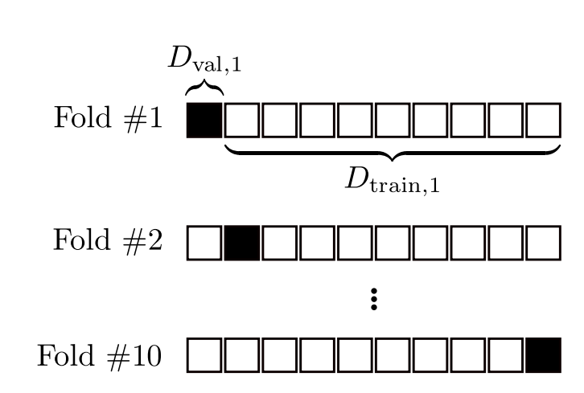

*Figure 49: K – Fold Cross-Validation [30].*

### Data Generation

With a certain amount of data for training and validation work, I have created a data generator class for the purpose of matching and optimizing the hardware in the training model, which has function generating an output with processed image and ground-truth masks. Specifically, the processed image, which is a reduction of the input image size by half from 1600 x 256 pixel to 800 x 128 pixel, dividing the number of input image into 16 batch sizes for each training epoch, moreover, the image has been normalized from RGB format with range 0 - 255 to grayscale format with range 0 – 1 that helps model easy to make a decision of being pixel of defect or not. Then the masks are 4 matrices with size 800 x 128 equivalent to the image, each matrix represents a defect type contained in the image, in which the pixel defined as defect having the value 1 and other ones without defect having a value of 0. These matrices are generated by decoding information from the EncodedPixels provided by the provider.

## Model

Basing on the achievements of state-of-the-art networks such as ResNet, EfficientNet, and U-Net. I have used two separate combinations: the combination of ResNet and U-Net, and the combination of EfficientNet and U-Net, where U-Net was the architecture acting as the main framework of the model, and Resnet and EfficientNet played a role as the backbone of the model, they replaced the original encoder part belonging to the U-Net architecture, with this combination there were models with a huge amount of parameters created, and with skip connections in the ResNet Blocks and compound scaling blocks in EfficientNet made it possible to train the model more deeply than the original one, which gave the model a very significant improvement.

**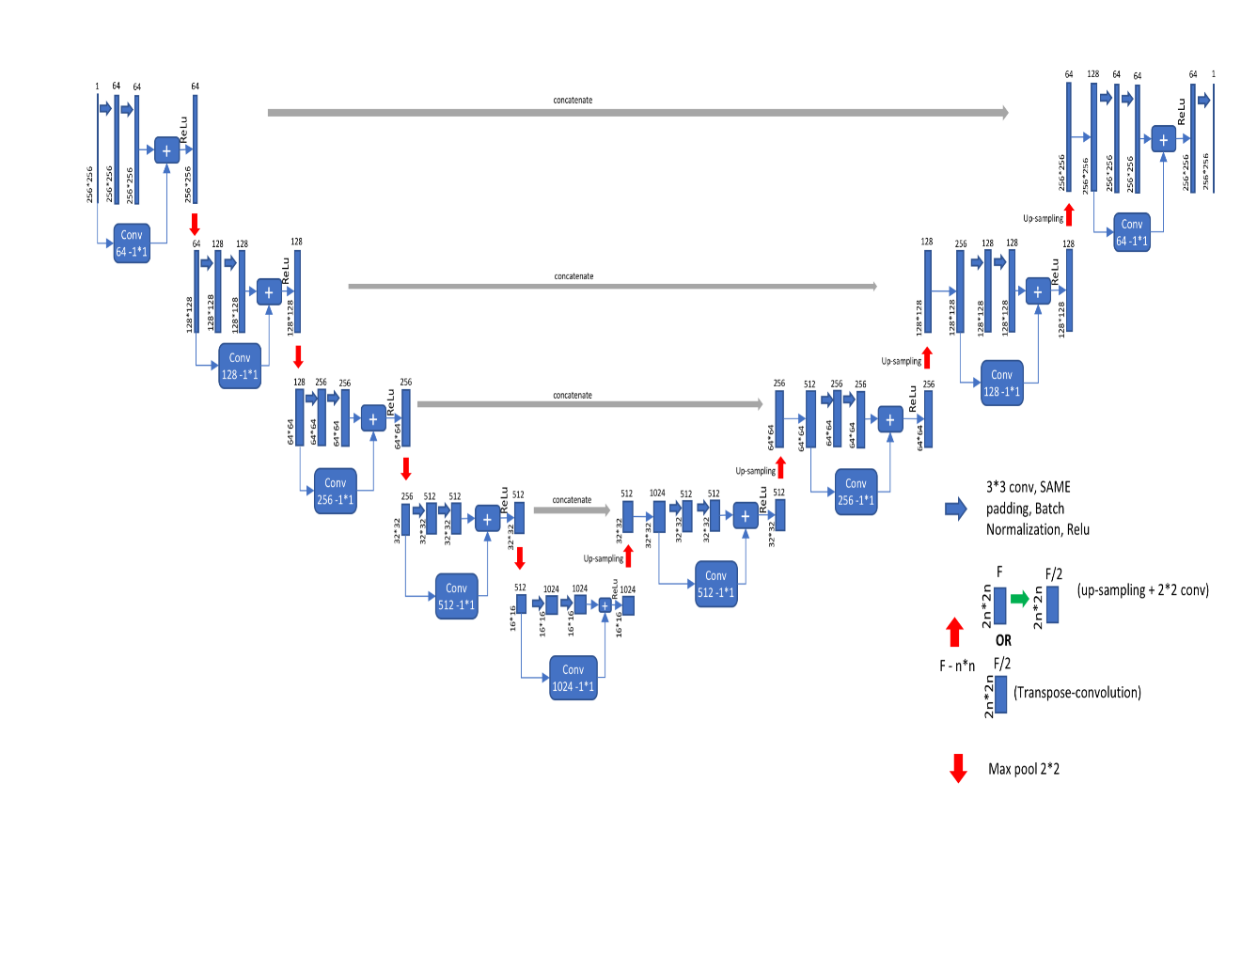***Figure 50: U-Net with ResNet as the backbone [34].*

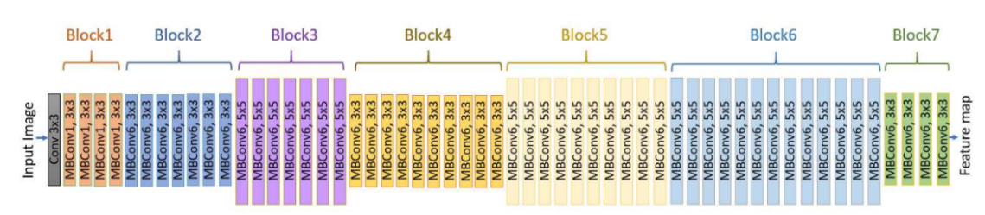

*Figure 51: EfficientNet-B7 architecture [31].*

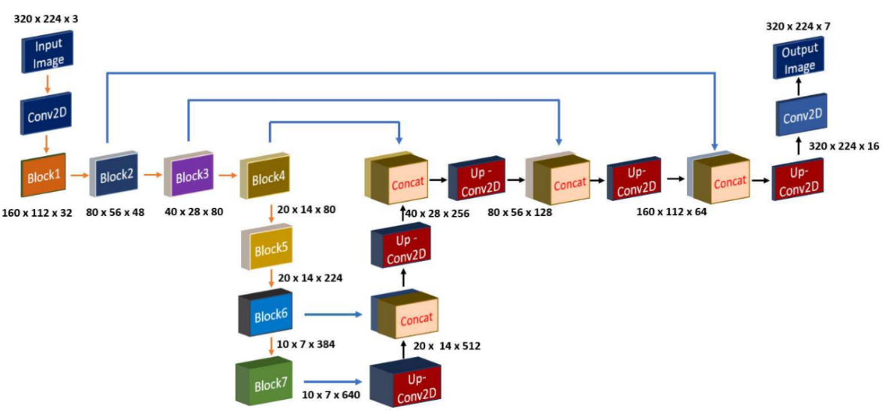

*Figure 52: U-Net with EfficientNet-B7 as backbone [31].*

### Evaluation Metrics

As the evaluation matrix for this thesis, I used the mean Dice coefficient that can be used to make a comparison about the pixel-wise agreement between a prediction of segmentation and its matching ground-truth mask. The dice coefficient is calculated by counting the similar pixels (taking intersections that appear in both images) in the two images being compared, multiplying it by 2, and dividing it by the total pixels of both images. The formula is shown in figure 53:

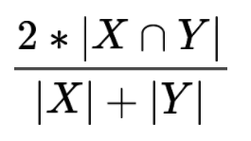

*Figure 53: Dice – Coefficient [36].*

where X presents for the set of predicted pixels and Y stands for the ground-truth mask.

### Loss function

For the purpose of detecting which pixels are defect or not on the input image, I have used the loss function of binary cross entropy for this thesis, with this loss function operating on the returned real numeric values in range 0 - 1, with values ​​>= 0.5 will be considered as defects, and vice versa values ​​< 0.5 will be considered as background.

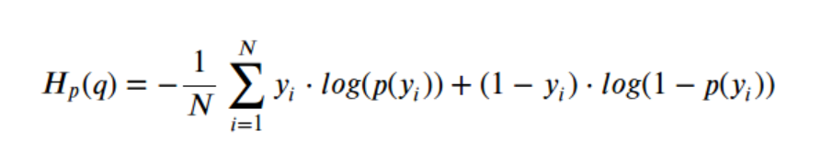

*Figure 54: Binary cross entropy [35].*

where y presents for the label (1 stands for pixels of defect and 0 stands for pixels of background) and p(y) stands for the probability of the predicted pixel that is defect for all N pixels [35]. The formula expresses that for each pixel of defect (y = 1), it is multiplied to log (p(y)) to the loss, which is, the log probability of its defect. Nevertheless, it will be multiplied to log (1 - p(y)), which is the log probability of it being background, for every pixel of background (y = 0) [35].

### Execution Environment

The thesis is used Colab Pro platform of Google, it is an application of cloud computing running Linux operating system, which provides a very useful tool with code cells and run time of python with version 3.7, quite similar to Annaconda notebook running on local machine. The platform offers quite a powerful hardware for ML as well as DL research, with GPU of NVIDIA TESLA P100 16GB, 27.3 GB for memory, and 168 GB for the local storage. This specification of hardware helps save training time and supply enough space for storing the data in research.

### Model Training Process

Implementing this idea, I have done experiments on several versions of combination of ResNet and U-Net, and some versions of combination of EfficientNet and U-Net. I have used transfer learning for all of the above architectures based on "Segmentation Models" library version 1.0.1, specifically with ResNet, I have used ResNet-34, ResNet-50, and ResNet-101 as backbone. On the opposite side, with EfficientNet, I use instances B0, B1, B3, B5 and B7 as the backbone of the model.

All versions of the model use the same loss function of binary cross entropy, and dice-coefficient as an evaluation matrix. Since the requirement is to identify 4 different types of defects, the number of classes needs to be segmented accordingly with the total number of defect types. The output layer of the model has a shape of 128 x 800 x 4 corresponding to the height, width, and number of defects, which is applied the sigmoid function as the AF. Furthermore, to help this model quickly converge, I have used pre-trained weights of "imagenet" corresponding to each type of backbone used, and the weights of this model encoder are frozen during training. Therefore, a huge number of parameters in the encoder part cannot be trained and only the remaining parameters in the decoder part are trained. Adding, the optimization method I use for the model is Adam.

In the training process, I used the K - fold method, with K = 5 to create a training and validation set with a ratio of 80 - 20 respectively in the total training data. The models are trained this bunch of data in 5 folds, each fold made a duty on running through 150 epochs, however, I implemented EarlyStopping callback with monitoring the change of "val_loss" value in range of 15 for patience value with mode is "min" aims to stop the training work when the model has reached the convergence point and there is no possibility of further improvement. With this selection of implementation, regular models are trained through a total of 90 - 120 epochs to reach convergence and for the EarlyStopping callback is executed.

And these implementations all yield positive and slightly different results.

# Result

After several experiments training the models, I have obtained relatively positive results. Specifically, after training for about 90 - 120 epochs out of a total of 5 folds, I went to evaluate the model with the set of validating and the set of testing that collected from the original set for training with 250 records. The average train loss and validation loss values of binary cross entropy accounted for the range of 0.0017 - 0.0031, because using the k-fold cross validation tactic which leads to the fact that the values of loss and validation loss are approximately equal, and this also happens with the average values of the evaluation matrix of dice coefficient in training and validation, specifically they accounted from 0.904 to 0.941. It is shown in the Figures 55.

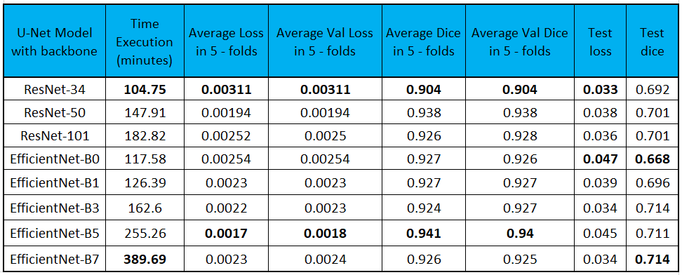

*Figure 55: Result of training models with evaluation values.*

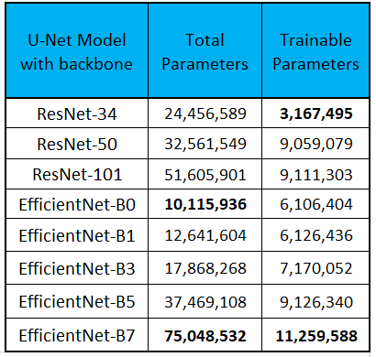

*Figure 56: Model Parameters.*

Based on Figure 55 we can see, the combination of ResNet-34 and U-Net gives the least efficient results, with results of the average loss of data set of training, validating, and testing were 0.00311, 0.00311, and 0.033 respectively. Moreover, average training and validating of dice coefficient had a value of 0.904, while the test dice coefficient came in at 0.692, which reached almost the bottom of the results. In contrast, the model with the EfficientNet-B5 backbone had the best results, with the average loss of set of training data and set of validating data, and loss of set of testing data values ​​of 0.0017, 0.0018, and 0.045, respectively. Then, not only the accuracy of dice coefficient in both training and validation accounted for 0.941 and 0.94, but also the test dice coefficient value reached to 0.711 being almost highest result of value. Looking at the results of the test dataset with 250 records, the model using EfficientNet-B0 gave the worst result with 0.047 for the test loss and 0.668 for the test dice coefficient. Oppositely, the model with EfficientNet-B7 backbone gave the best and most optimal results for loss test and dice coefficient test, which accounted for values ​​of 0.034 and 0.714 respectively.

Furthermore, when looking at both Figure 55 and Figure 56, we see that the number of trainable parameters between the models were not the same, with the models with the fewest number of trainable parameters giving the lowest results and the least time cost for training, specifically, ResNet-34 backbone gave us more than 3M trainable parameters and only took more than 104 minutes to perform the training task. Whereas EfficientNet-B7 backbone was the choice that consumes the most parameters and execution time and also brought the best results for the test set, with more than 11M trainable parameters they took more than 389 minutes to train the model.

Evaluation of the performance of the classification model is next step, it is to use "accuracy_score" and "multilabel_confusion_matrix" functions provided by the “Sklearn” library. With the "accuracy_score" function, I performed the aggregation of the image's ground-truth masks as a value of the "y_true" parameter and synthesized the predicted masks of each image as a value of the "y_pred" parameter, then I used them to perform a general evaluation of accuracy for set of test data with non-single defect types, which is supposed to be how many defect types appear on an image, used its results to calculate an average result of accuracy score. And then it was an evaluation step for each defect type separately. After that, with the use of "multilabel_confusion_matrix" function to help give the number of matrices corresponding to the number of defect types to be predicted, here with 2 parameters "y_pred" and "y_true" used in this function returned the result as 4 matrices, in each matrix encloses the number of records of false negative (FN), true negative (TN), false positive (FP), and true positive (TP) results on total number of records of the test data set. The Figure 57 shows particular results.

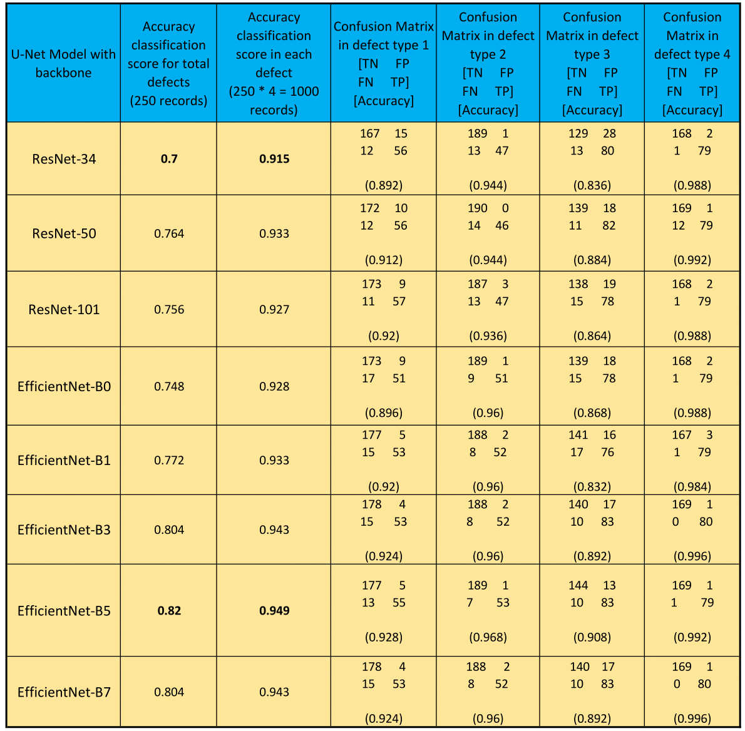

*Figure 57: Accuracy Scores and Confusion Matrix Result of Training Models.*

Looking at Figure 57, the model using ResNet-34 as the backbone has the lowest accuracy score for the total number of defect types as well as for each defect type, with results of 0.7 and 0.915 respectively. Meanwhile, the model using EfficientNet-B5 as backbone has the best accuracy score with 0.82 for total defect types, and 0.949 for each defect type. In addition to these 2 options, we have 2 other options with the same very good results, these are EfficientNet-B3 and EfficientNet-B7 as backbone with 2 pairs of results being 0.804 - 0.943 for accuracy score of total defect types and each defect type.

Subsequently, the results of using confusion matrix for model evaluation, overall, all the models have a pretty good result above 0.83. Specifically, there was the lowest result in defect type 3 with the values ​​ranging between 0.832 - 0.908. However, the prediction of defect types 1, 2 and 4 yielded more impressive results, with types 1 and type 2 giving fluctuating results in the range of 0.89 - 0.96, in particular, type 4 gave excellent results at approximately above 0.98.

Based on the above results, we can conclude that, with the combination of ResNet-34 and U-Net gave a less optimal result, on the contrary, using EfficientNets-B5 and U-Net gave the most optimal results with the highest and closest accuracy values ​​in these versions and a reasonable execution time, it spent 255.26 minutes for training model work. Although the use of EfficientNet-B7 got a slightly better result, we had to trade off the execution time of up to 389.69 minutes for the training model.

The Figure 58, 59 show the results of dice coefficient and loss in both training and validation data set in the combination of ResNet-101 and U-Net model.

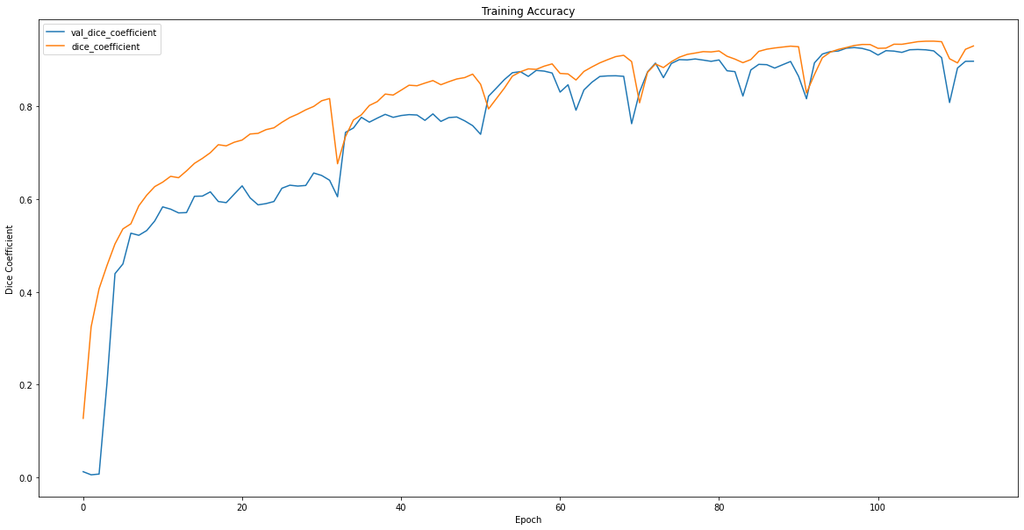

*Figure 58: Dice coefficient on data of training and validating in ResNet101 - U-Net model*

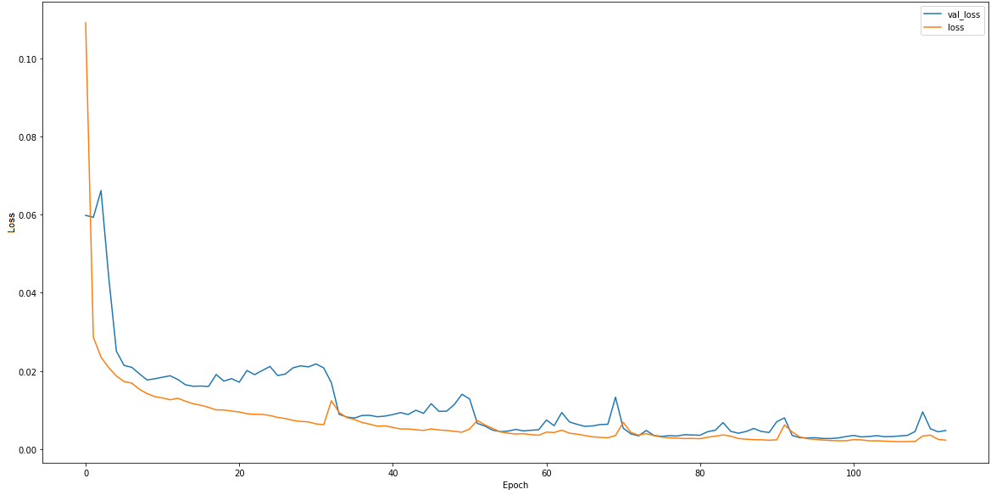

*Figure 59: Loss on data of training and validating in ResNet101 - U-Net model*

The Figure 60, 61 show the results of dice coefficient and loss in both training and validation data set in the combination of EfficientNet-B5 and U-Net model.

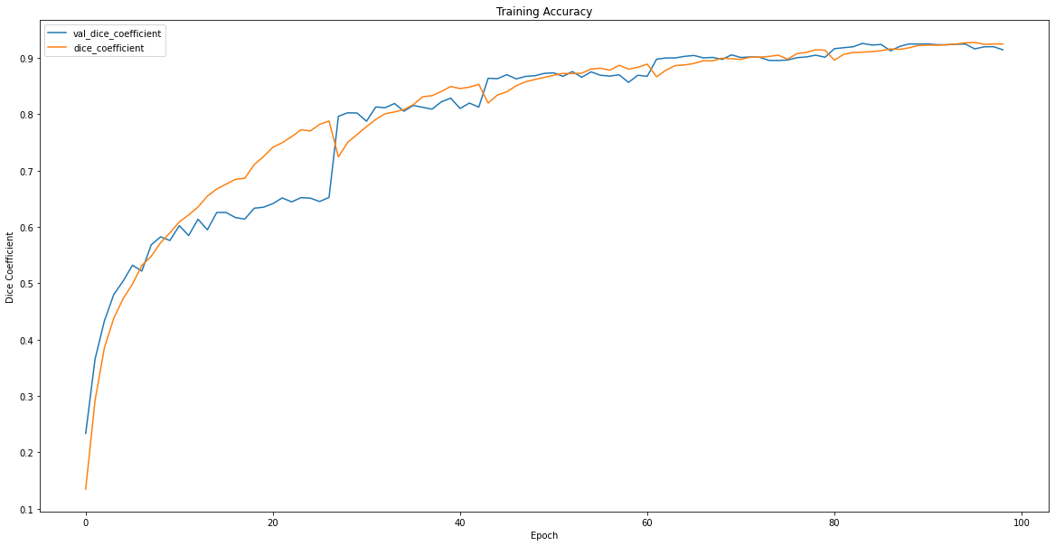

*Figure 60: Dice coefficient on data of training and validation in EfficientNet-B5 - U-Net model*

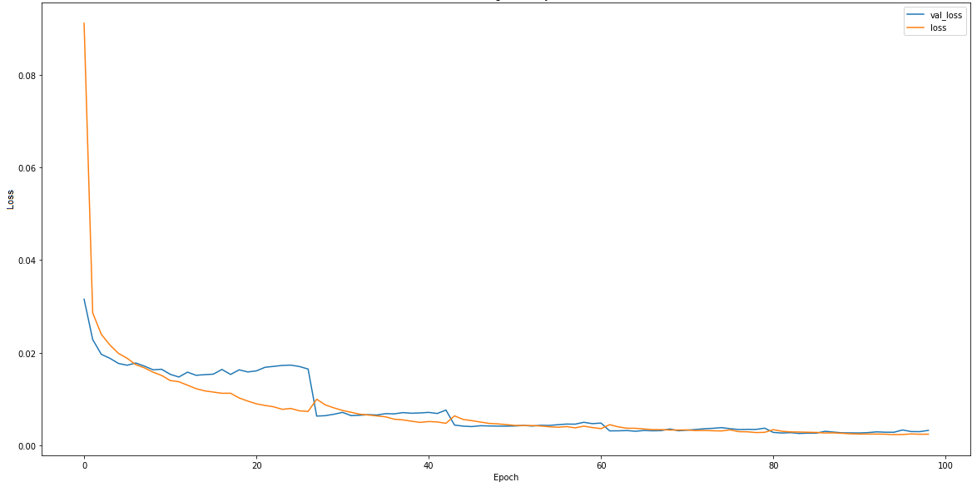

*Figure 61: Loss on data of training and validation in EfficientNet-B5 - U-Net model*

Figure 62 and 63 show the results of image prediction in validation and test data set in the combination of ResNet-101 and U-Net model and Figure 64 and 65 show the results of image prediction in validation and test data set in the combination of EfficientNet-B5 and U-Net model. The predicted label based on the number of pixel that model marked as the defect, the defect type will be supposed a defect if there are more than 200 pixels of being predicted defect.

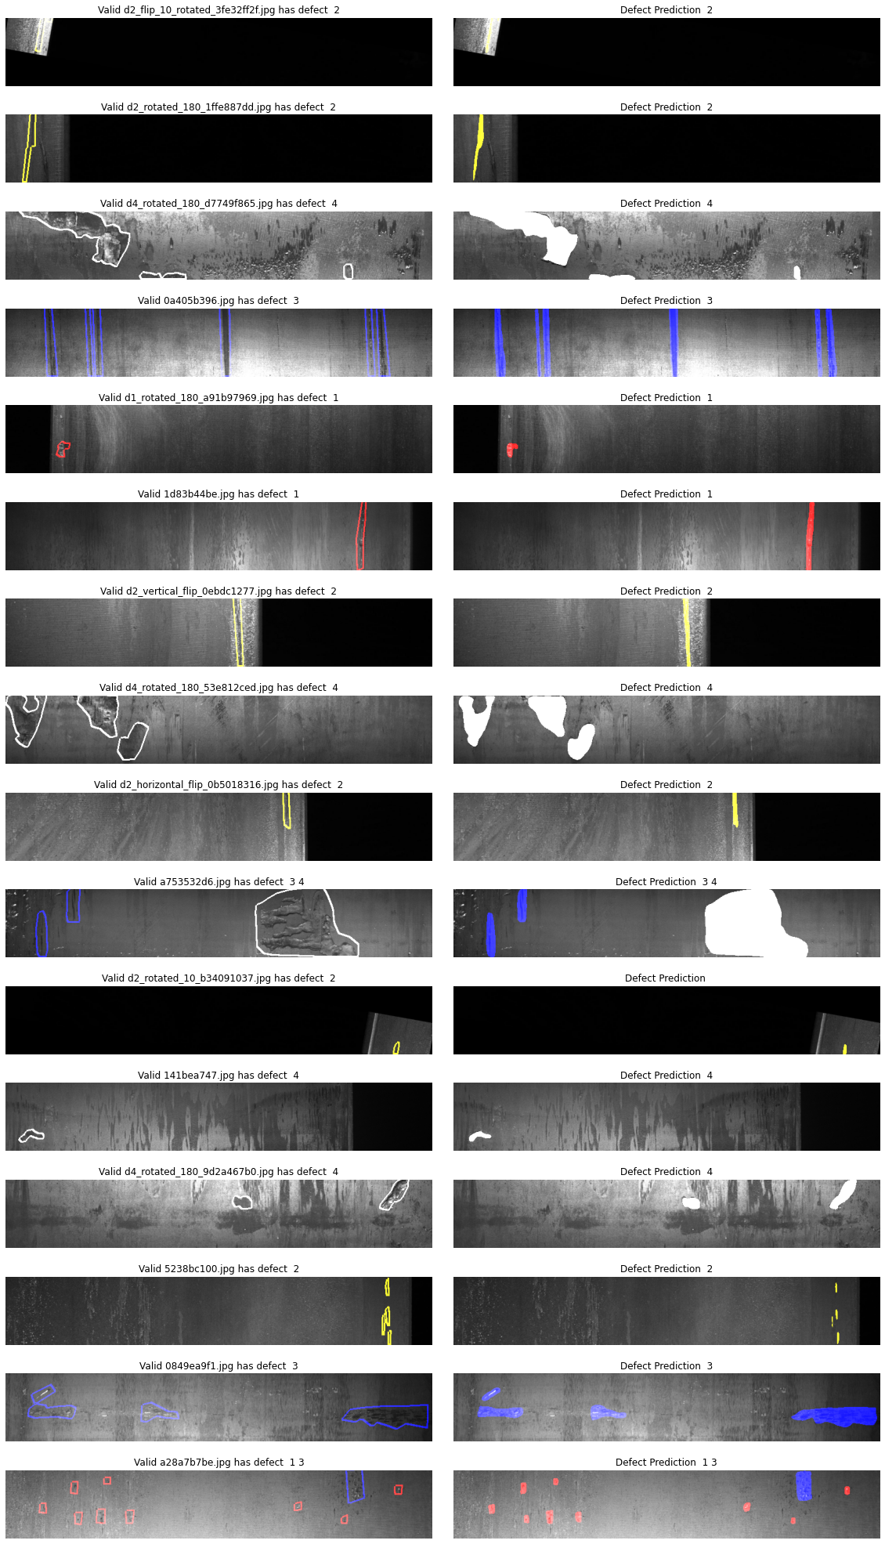

*Figure 62: Prediction result on validation data in ResNet-101 – U-Net model with ground-truth compare to predicted masks.*

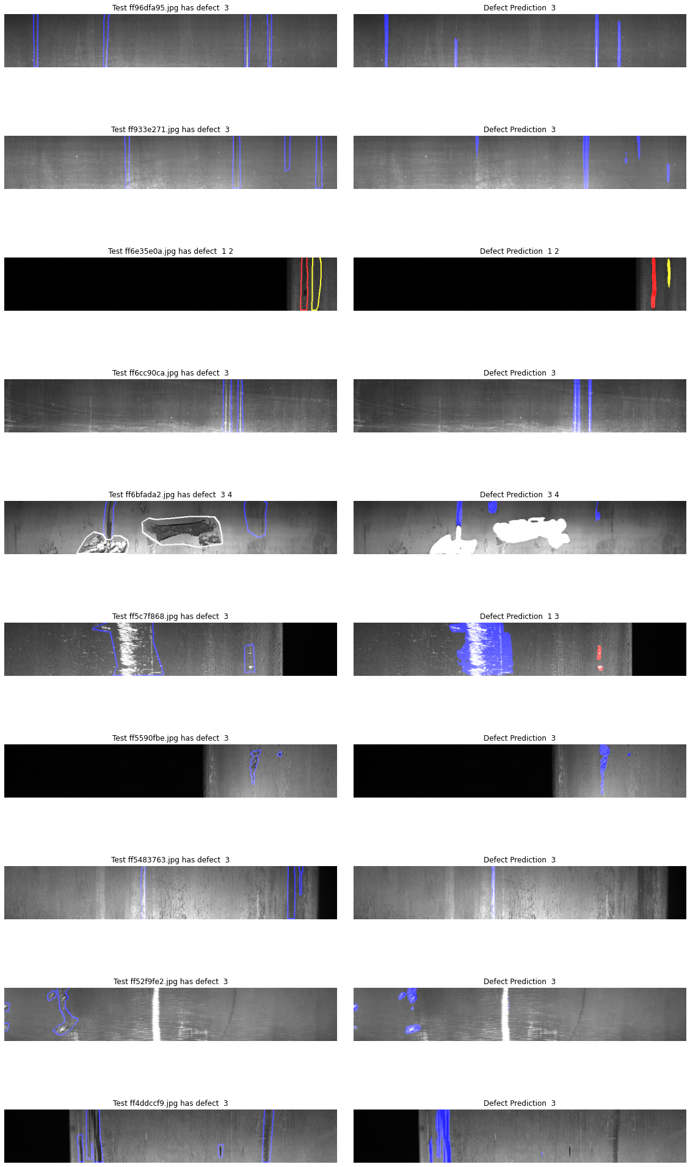

*Figure 63: Prediction result on test set in ResNet-101 – U-Net model with ground-truth compare to predicted masks.*

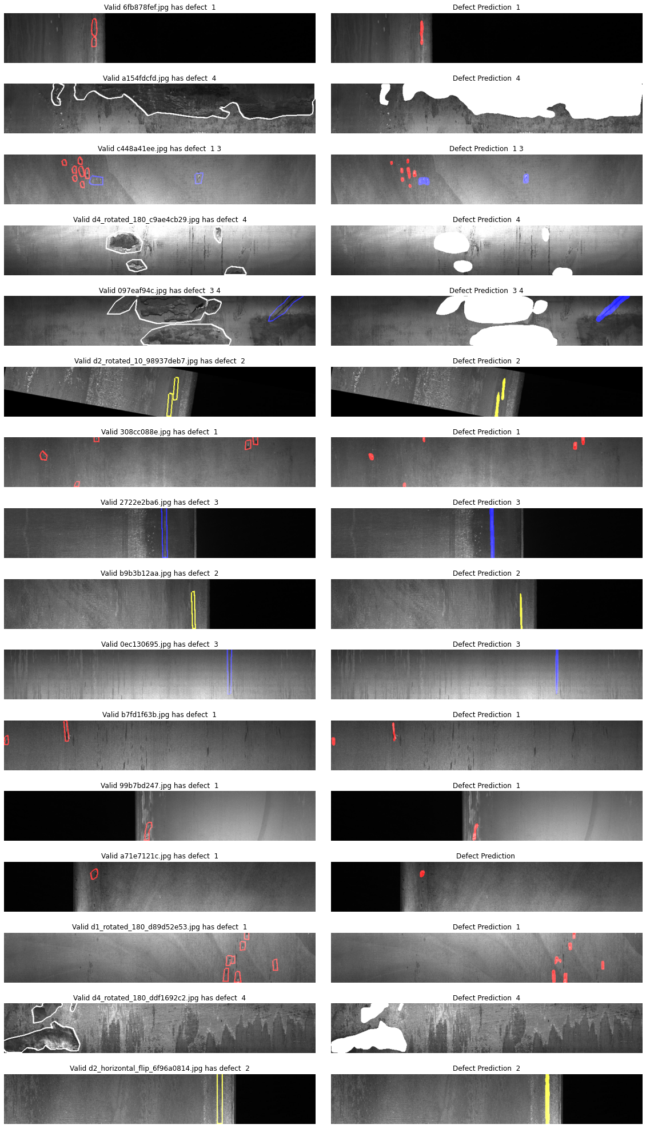

*Figure 64: Prediction result on validation data in EfficientNet-B5 – U-Net model with ground-truth compare to predicted masks.*

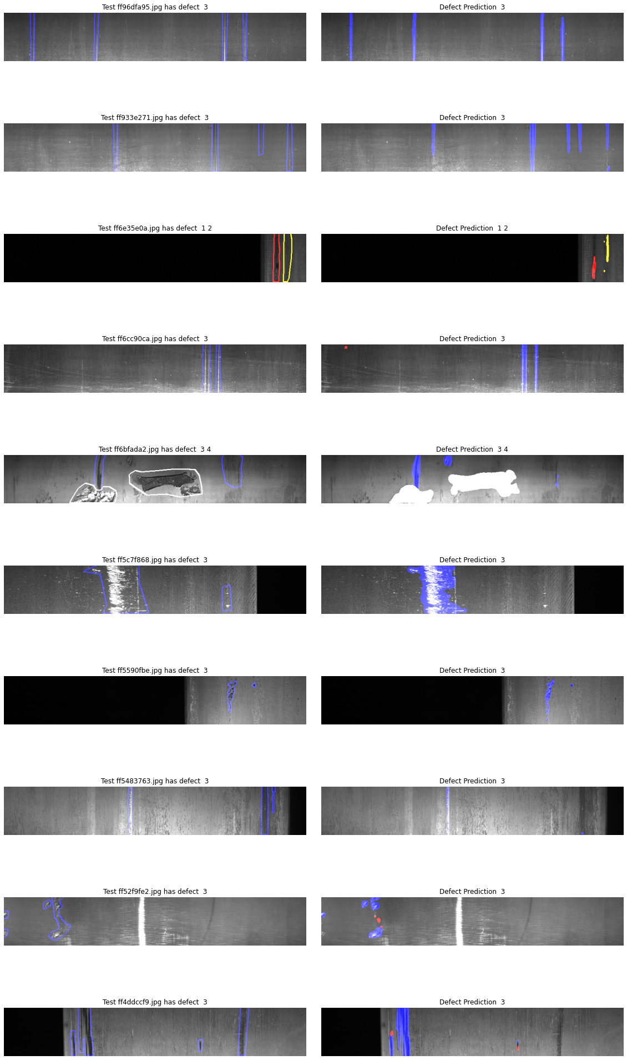

*Figure 65: Prediction result on test data in EfficientNet-B5 – U-Net model with ground-truth compare to predicted masks.*

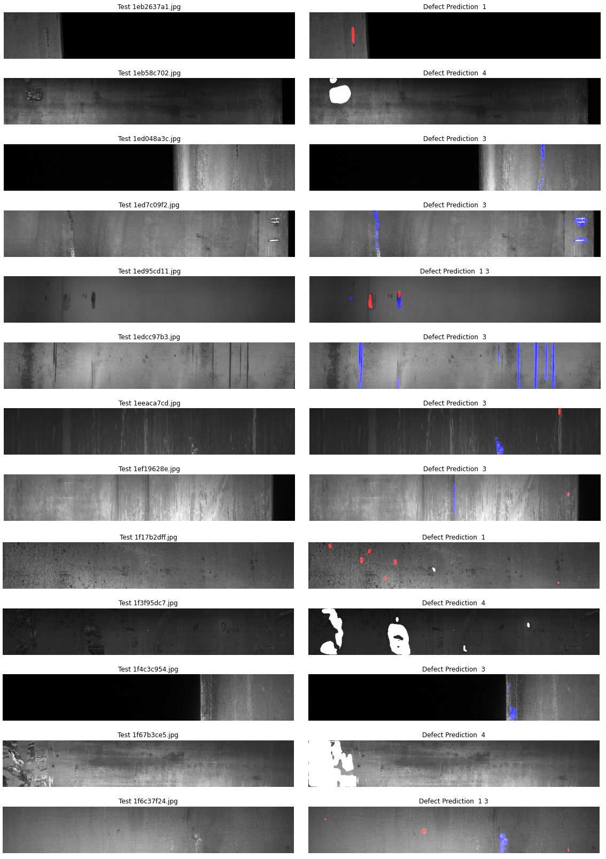

*Figure 66: Prediction result on some original test data without ground-truth masks in EfficientNet-B5 – U-Net model*

# Future Work Scope

With a pretty good result when the dice coefficient of validation data reaches 0.94 and 0.71 on the test set with ground-truth masks taken from the training set, this model should be further improved in the future. I plan to find a way to fine-tuning the model for a better result, or another approach based on other state-of-the-art works. Actually, in this project with this same data set, many people or teams have come up with better solutions with the result of dice coefficient of validation reaching 0.98 even though there is no verifiable result on test data set, because the supplier did not give out a test data set with ground-truth masks to be able to re-evaluate the model in the most objective way. Also, based on this result, maybe in the future I will learn about and develop them to a backend server to provide a direct API for mobile devices or IOT devices, specifically here devices including camera, which aims to predict steel images containing defects through camera scanning. And another scope is learning and researching how to integrate inference model function on Android platform based on TensorFlow Lite that google provides, it helps to integrate offline model on android devices which is also an interesting idea.

# Conclusion

In conclusion, with the problem posed to detect defects on images of steel surfaces, along with basing on the background knowledge of ML as well as DL, and applying state-of-the-art works in DL, specifically, the combination of ResNets and U-Net architectures, and the combination of EfficientNets and U-Net architectures, the thesis gives a relatively satisfactory result for this problem, which is using semantic segmentation based on these complex architectures with binary cross entropy of loss and dice coefficient for evaluation metrics, fine-tuning with pre-trained weights of "imagenet" corresponding to backbone type of model and Adam as an optimizer. And cannot be lacking of making training data balanced. This strategy of implementation gave out the best validation of loss about 0.0018 and best validation of dice coefficient about 0.94, although it is not the best result, it is suitable in research and academic scope. Besides, because my ability is within the scope of study and research, the thesis cannot avoid shortcomings and limitations in achieving an excellent result. Hopefully, this thesis can contribute something in the practical application of the problem of identifying defects on the surface of steel and materials in general, and a better solution will be found to reach a higher improvement in the future.

# Bibliography

[1] G. Cybenko, “*Approximation by superposition of a sigmoidal function*”, Math. Control Signals Systems, 1989.

[2] F. Chollet. “*Deep Learning with Python*”, Manning, Shelter Island, NY, USA, 1st edition, 2017

[3] I. Goodfellow, Y. Bengio, and A. Courville. “*Deep Learning (Adaptive Computation and Machine Learning Series*”, MIT Press, Cambridge, MA, USA, 2016.

[4] <https://www.ibm.com/cloud/learn/gradient-descent>

[5] Sebastian Ruder. “*An overview of gradient descent optimization algorithms*”

[6] <https://builtin.com/data-science/gradient-descent>

[7] P. Wang, P. Chen, Y. Yuan, D. Liu, Z. Huang, X. Hou, and G. Cottrell. “*Understanding convolution for semantic segmentation. In IEEE Winter Conference on Applications of Computer Vision (WACV)*”, pages 1451 - 1460, March 2018.

[8] Kunihiko Fukushima, “*Neocognitron: A self-organizing neural network model for a mechanism of pattern recognition unaffected by shift in position*”, Biological cybernetics, vol. 36, no. 4, pp. 193–202, 1980.

[9] <https://cs231n.github.io/convolutional-networks/>

[10] Jonathan Long, Evan Shelhamer, and Trevor Darrell, “*Fully convolutional networks for semantic segmentation*”, in Proceedings of the IEEE conference on computer vision and pattern recognition, 2015, pp. 3431–3440.

[11] Joseph Redmon, Santosh Divvala, Ross Girshick, and Ali Farhadi, “*You only look once: Unified, real-time object detection*”, in Proceedings of the IEEE conference on computer vision and pattern recognition, 2016, pp. 779–788.

[12] A. Krizhevsky, I. Sutskever, and G. E. Hinton, “*Imagenet classification with deep convolutional neural networks*”, 2012.

[13] J. Han and C. Moraga, “*The influence of the sigmoid function parameters on the speed of backpropagation learning,*” in Natural to Artificial Neural Computation. IWANN 1995. Lecture Notes in Computer Science. Berlin, Heidelberg: Springer, 1995, pp. 195–201.

[14] Y. LeCun, Y. Bengio, and G. Hinton, “*Deep learning,*” Nature, vol. 521, no. 7553, pp. 436–444, 2015.

[15] B. Karlik and A. Vehbi, “*Performance Analysis of Various Activation Functions in Generalized MLP Architectures of Neural Networks,*” International Journal of Artificial Intelligence and Expert Systems (IJAE), vol. 1, no. 4, pp. 111–122, 2011.

[16] Y. N. Dauphin, A. Fan, M. Auli, and D. Grangier, “*Language Modeling with Gated Convolutional Networks,*” arXiv, 2017.

[17] V. Nair and G. E. Hinton, “*Rectified linear units improve restricted Boltzmann machines,*” Haifa, 2010, pp. 807–814.

[18] M. D. Zeiler, M. Ranzato, R. Monga, M. Mao, K. Yang, Q. V. Le, and G. E. Hinton, “*On rectified linear units for speech processing,*” in International Conference on Acoustics, Speech and Signal Processing. IEEE, 2013, pp. 3517–3521

[19] X. Glorot, A. Bordes, and Y. Bengio, “*Deep Sparse Rectifier Neural Networks,*” in International Conference on Machine Learning, 2011

[20] Kaiming He, Xiangyu Zhang, Shaoqing Ren, and Jian Sun. “*Deep residual learning for image recognition*”

[21] <https://viso.ai/deep-learning/resnet-residual-neural-network/>

[22] <https://towardsdatascience.com/understanding-and-visualizing-resnets-442284831be8>

[23] <https://medium.com/@nainaakash012/efficientnet-rethinking-model-scaling-for-convolutional-neural-networks-92941c5bfb95>

[24] <https://ai.googleblog.com/2019/05/efficientnet-improving-accuracy-and.html>

[25] Mingxing Tan, Quoc V. Le, “*EfficientNet: Rethinking Model Scaling for Convolutional Neural Networks*”

[26] <https://www.mygreatlearning.com/blog/fcn-fully-convolutional-network-semantic-segmentation/>

[27] Olaf Ronneberger, Philipp Fischer, and Thomas Brox. “*U-net: Convolutional networks for biomedical image segmentation*”.

[28] <https://towardsdatascience.com/optimizers-for-training-neural-network-59450d71caf6>

[29] <https://ruder.io/optimizing-gradient-descent/index.html#momentum>

[30] <https://www.researchgate.net/publication/324701535_Cross-Validation>

[31] [Bhakti Baheti](https://ieeexplore.ieee.org/author/37085557222), [Shubham Innani](https://ieeexplore.ieee.org/author/37088449105), [Suhas Gajre](https://ieeexplore.ieee.org/author/37352126100), [Sanjay Talbar](https://ieeexplore.ieee.org/author/37393596100), “*Eff-UNet: A Novel Architecture for Semantic Segmentation in Unstructured Environment*”

[32] <https://medium.com/@wilburdes/semantic-segmentation-using-fully-convolutional-neural-networks-86e45336f99b>

[33] <https://medium.com/@danqing/a-practical-guide-to-relu-b83ca804f1f7>

[34] <https://medium.com/@nishanksingla/unet-with-resblock-for-semantic-segmentation-dd1766b4ff66>

[35] <https://towardsdatascience.com/understanding-binary-cross-entropy-log-loss-a-visual-explanation-a3ac6025181a>

[36] <https://www.kaggle.com/c/severstal-steel-defect-detection/>

[37] <https://www.expert.ai/blog/machine-learning-definition/>

[38] <https://www.ibm.com/topics/computer-vision>

[39] <https://xd.adobe.com/ideas/principles/emerging-technology/what-is-computer-vision-how-does-it-work/>

[40] <https://medium.com/analytics-vidhya/image-classification-vs-object-detection-vs-image-segmentation-f36db85fe81>

[41] <https://viso.ai/deep-learning/image-segmentation-using-deep-learning/>

[42] <https://developer.nvidia.com/deep-learning>

[43] <https://www.geeksforgeeks.org/object-detection-vs-object-recognition-vs-image-segmentation/>

[44] <https://towardsdatascience.com/hyper-parameter-tuning-techniques-in-deep-learning-4dad592c63c8>

[45] <https://medium.com/swlh/fully-connected-vs-convolutional-neural-networks-813ca7bc6ee5>

[46] <https://towardsdatascience.com/statistics-is-freaking-hard-wtf-is-activation-function-df8342cdf292>

[47] <https://study.com/academy/lesson/how-to-recognize-linear-functions-vs-non-linear-functions.html>